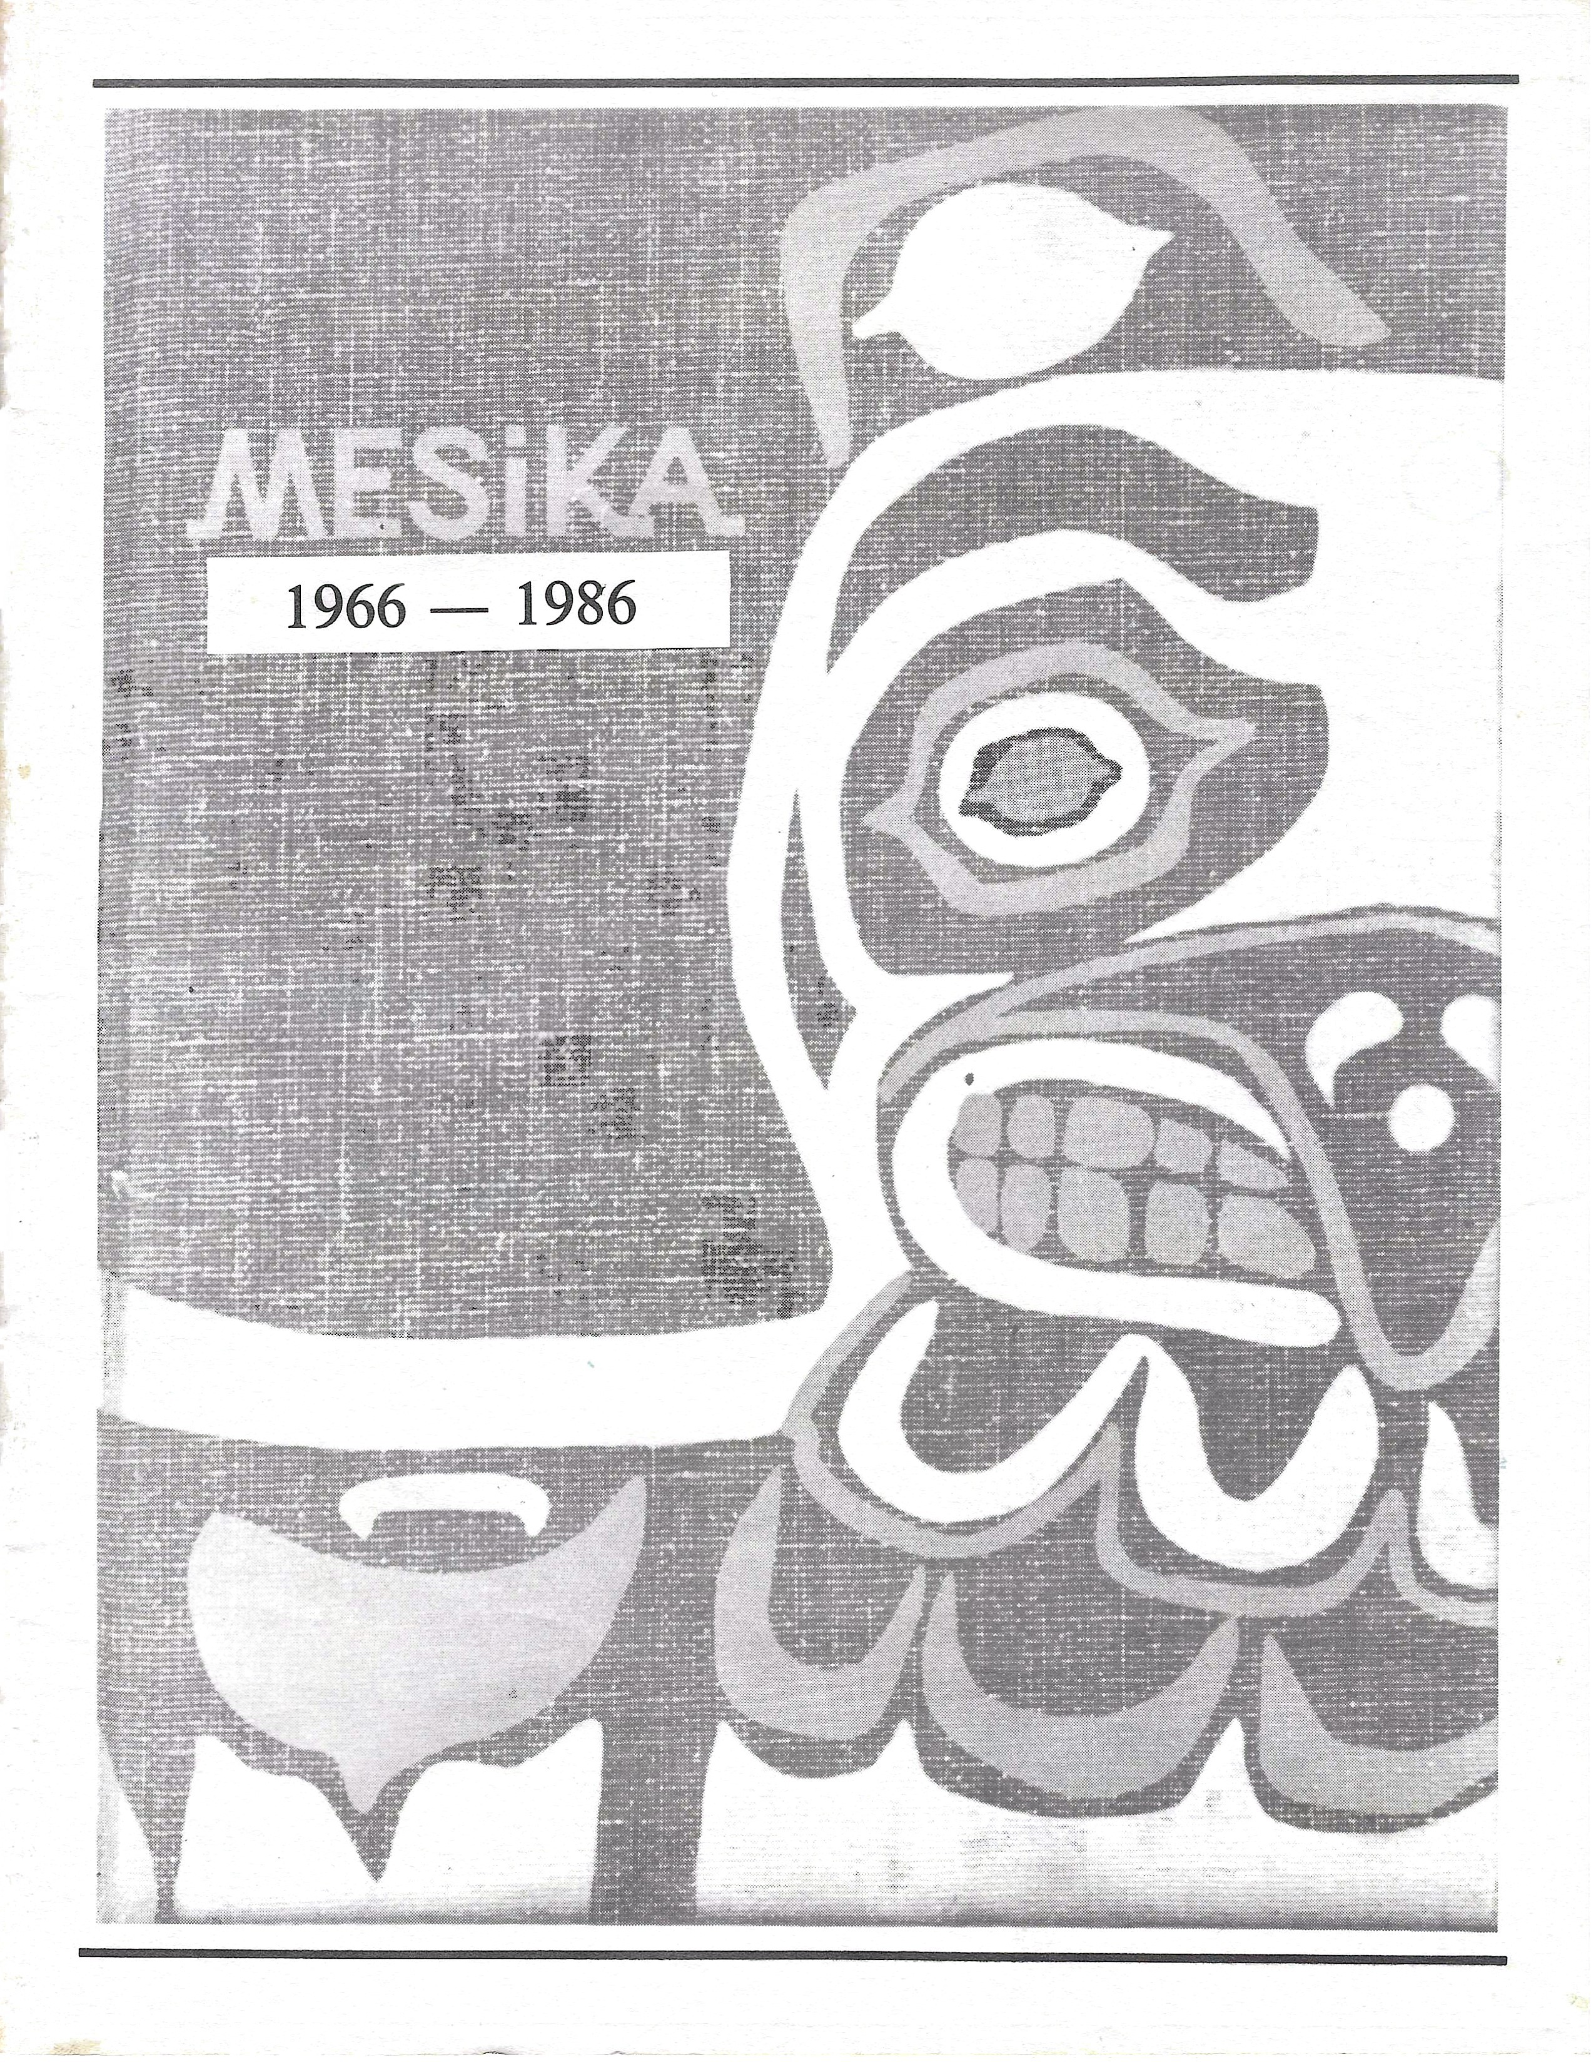

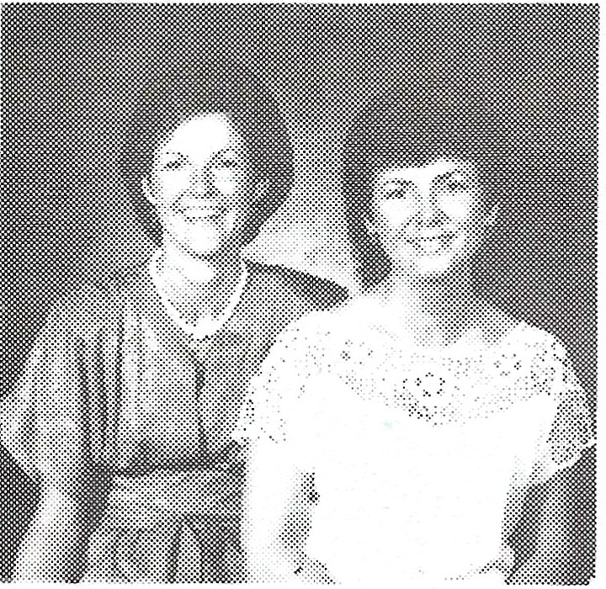
REUNION COMMITTEE

Marilyn Miller Echelbarger & Pam Mitcham Jones Chairpersons

Sheryl Krizan Withrow, Linda Christenson Aardahl, Sherry & Dick Haigh, Marie Cameron Hodges (not pictured), Lois Manley Parks, Gerry Ritchey Reed, Greg Olson, Patty Eisen Yeakley, Ginger Jay Kohler (not pictured)
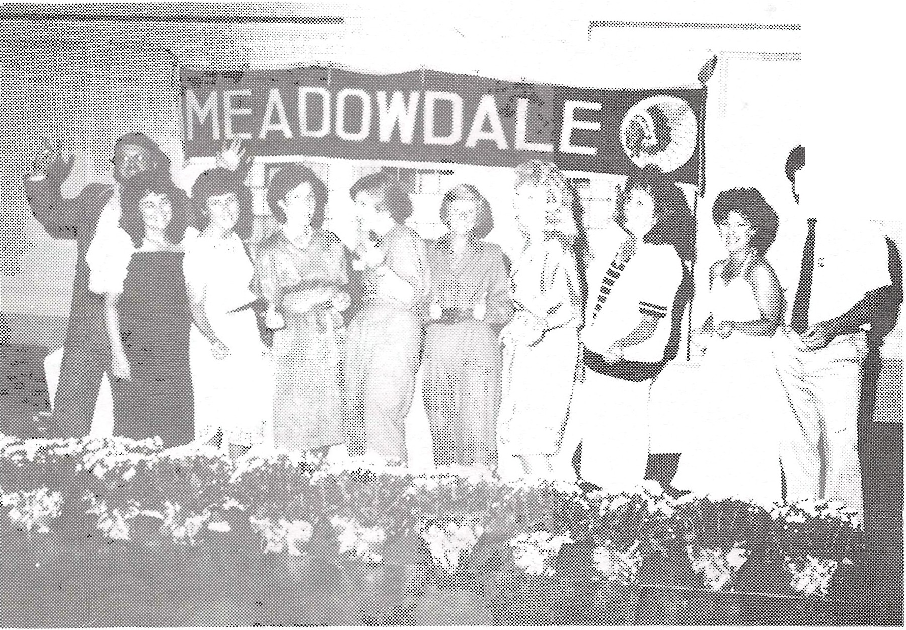

...· l
>i11. ;· "\ ·
{{Ji. .\ ....

SPECIAL THANKS TO:

Ann Marshall for typing the Biographical Data Section of this annual and to Sandy LaRue for the floral arrangements.

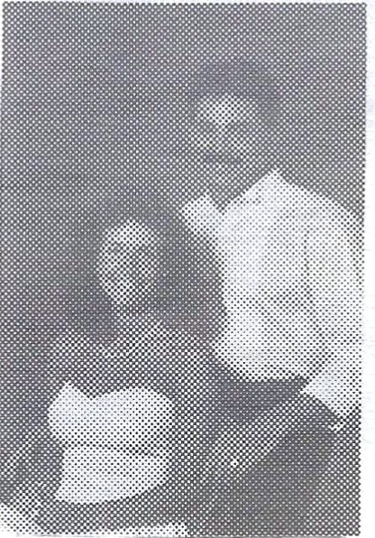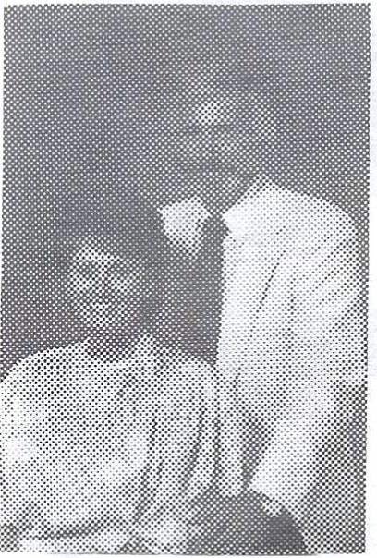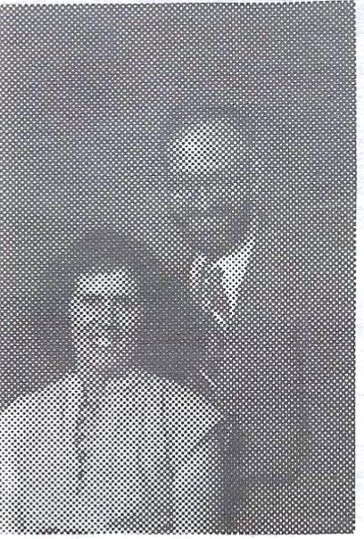

Alton Akers (Marti)
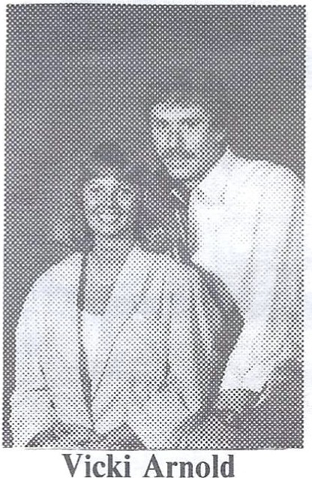

(Del)
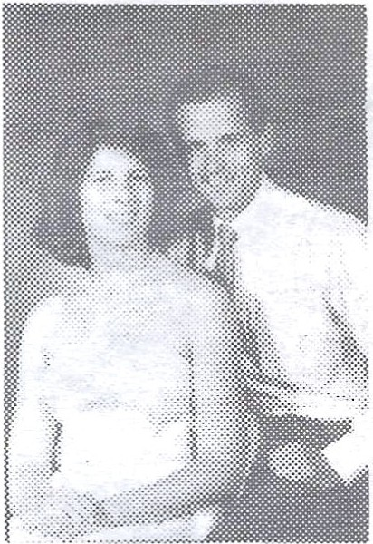

Mel Bowman (Jeri Beth)
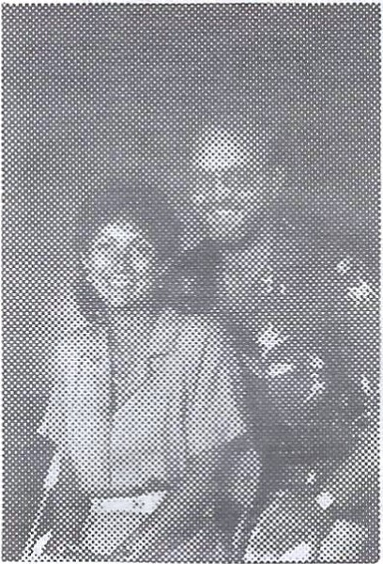

Barbara Brown Bob Christopher
Billie Alguard (Len)
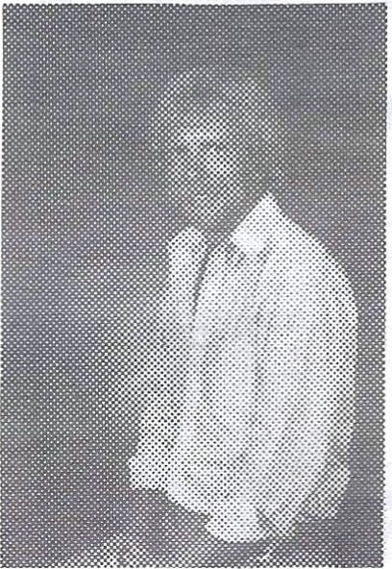

Dave Aspens
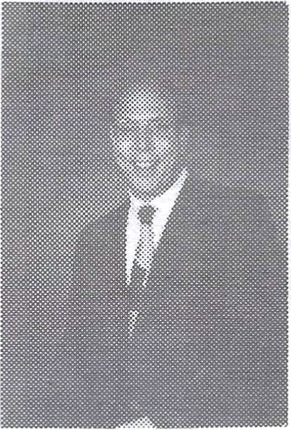

Kevin Brechner
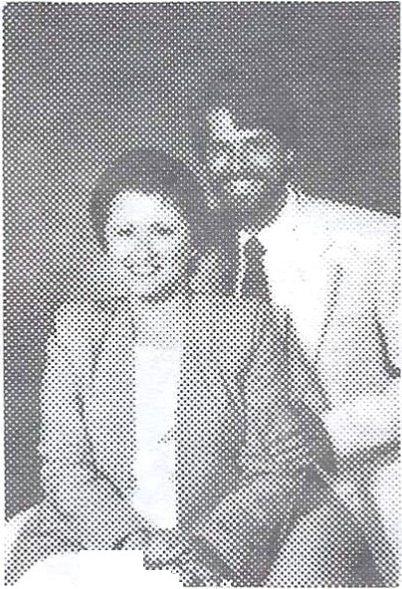
,:..::.·.::::::::::...

Dennis Brown
Robert Aline (Rosemary)
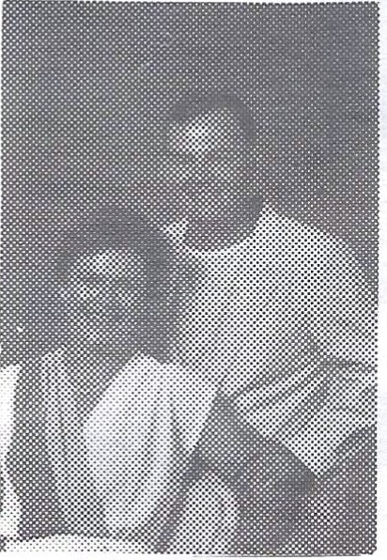

Mike Burton (Susan)
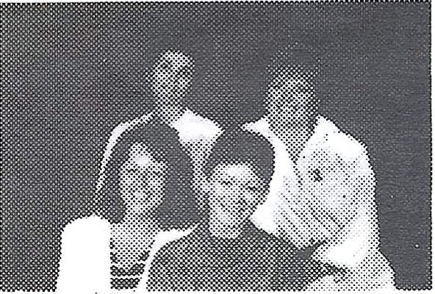

Sherri Briggs Becky Backes Teri Williams Sheryl Krizan

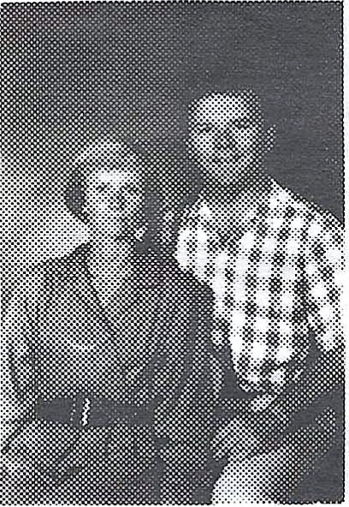

Linda Christenson (Darrell)
Richard Anderson (Karen
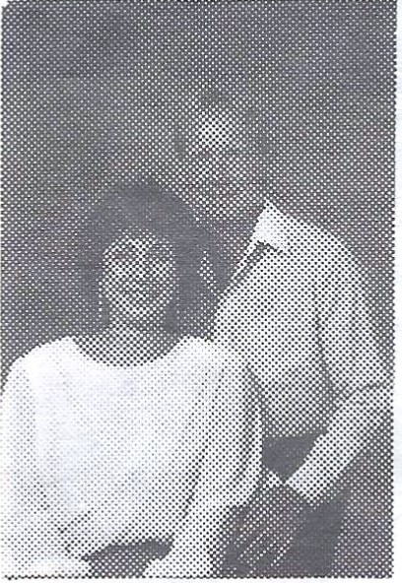

Dick Birkenbuel (Susan)
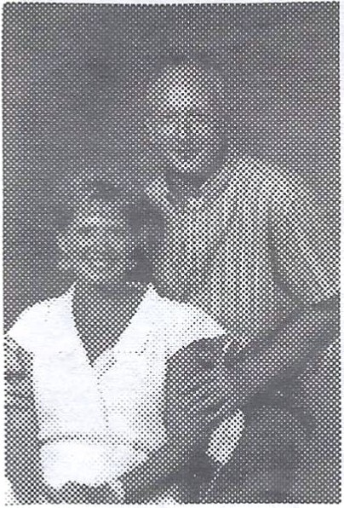

Helen Beckman (Bernie)
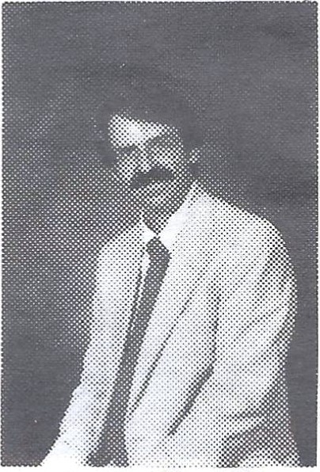

Roger Clement

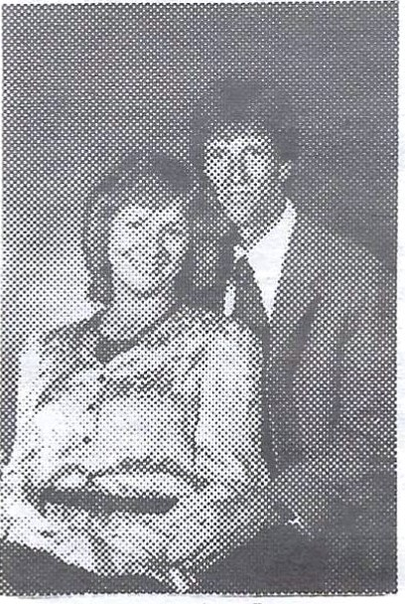

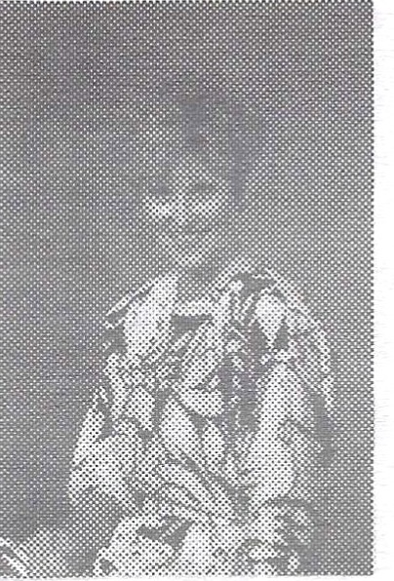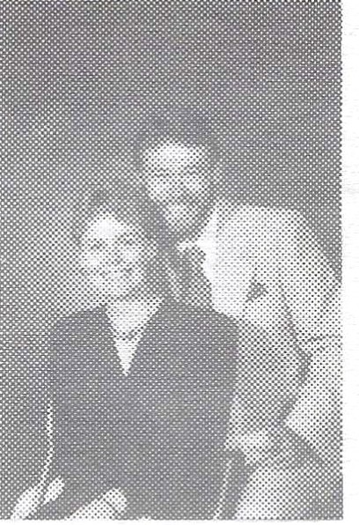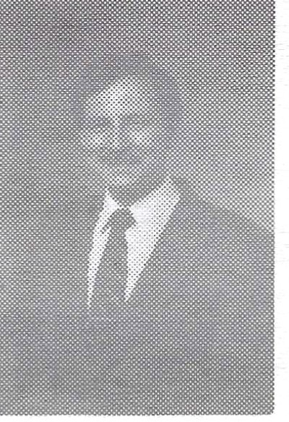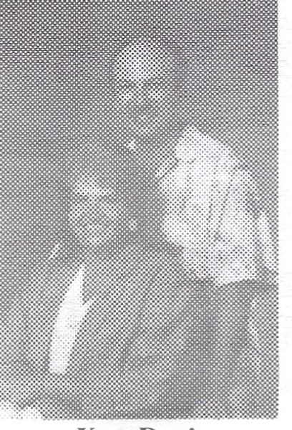

Susan Coleman
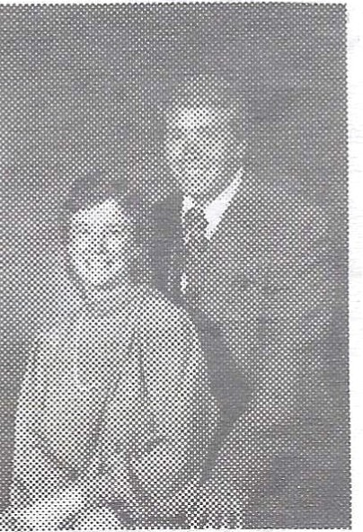

Jack Davidson (Cecile)
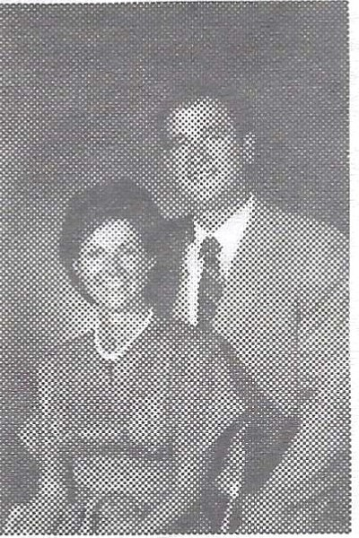

Marilyn Miller Pat Echelbarger
James Conner (Candice)
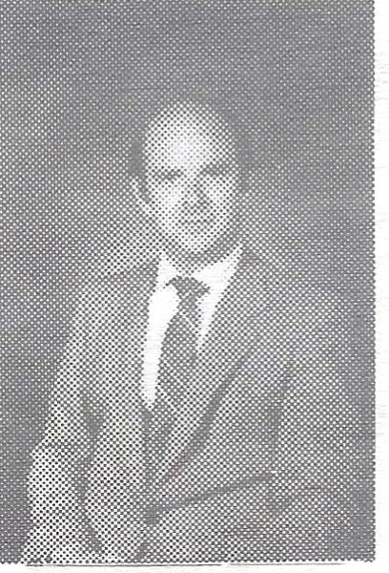

Greg Delamarter
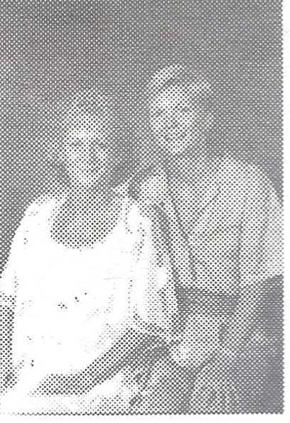

Jean & Joan Elvin
Steve Dauzenroth
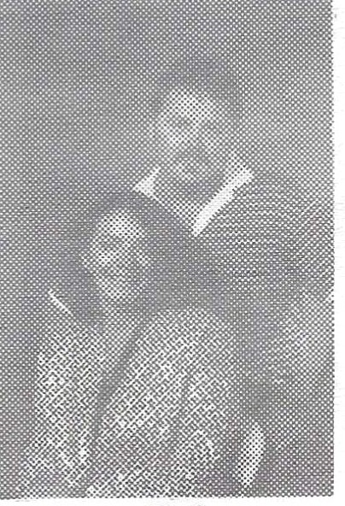

Steve DeLong (Bea)
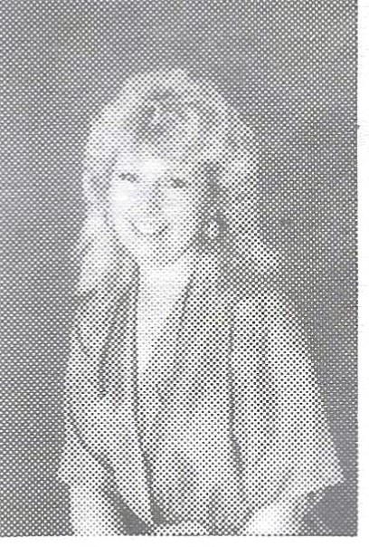

Patty Eisen
Ken Davis (Kathy)
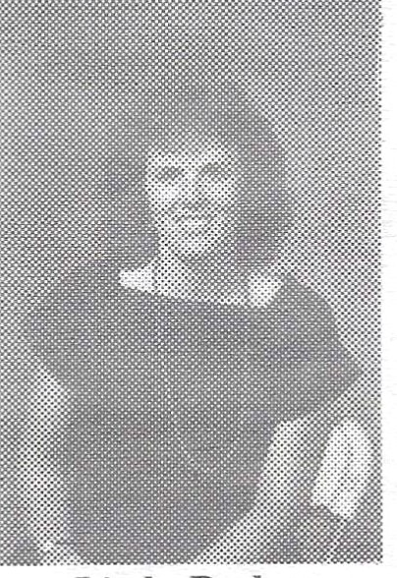

Linda Dodge
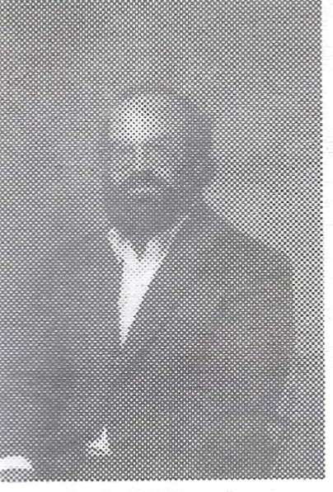

Keith Fletcher

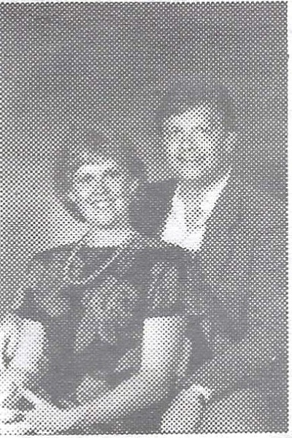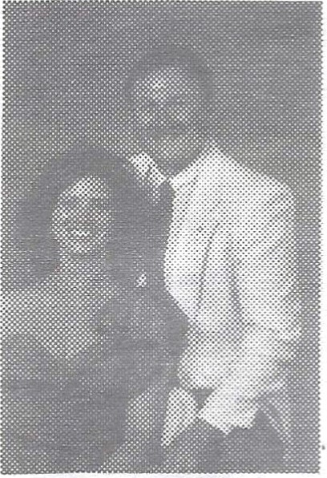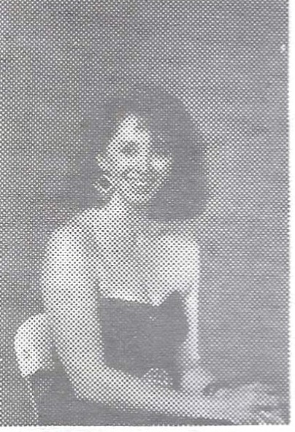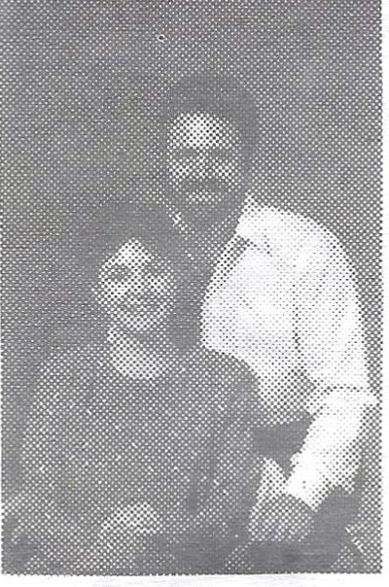

Ron Freer (Wendy)
Ray Forsythe (June)
Kathy Gilmore Gary Goebel (Bobbi)

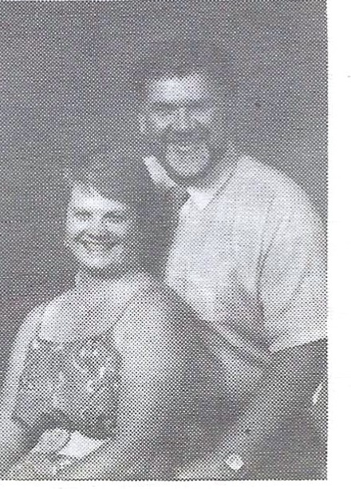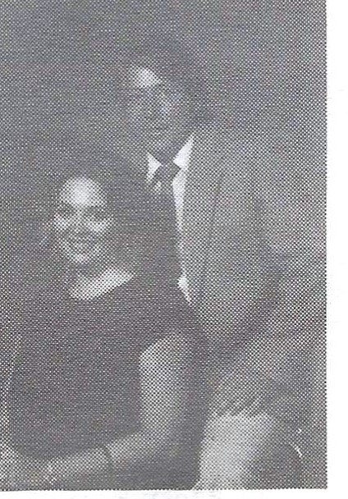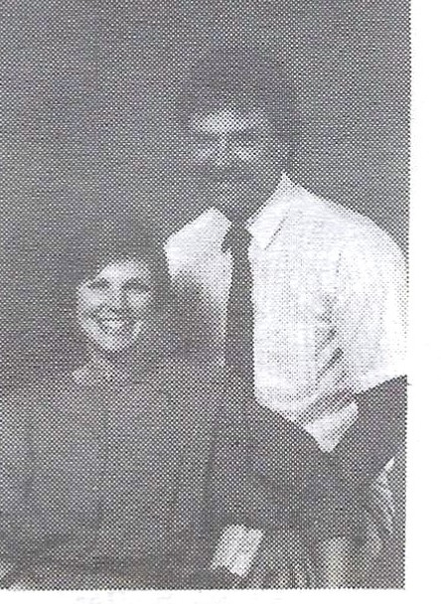

Dennis Gorley (Glena)
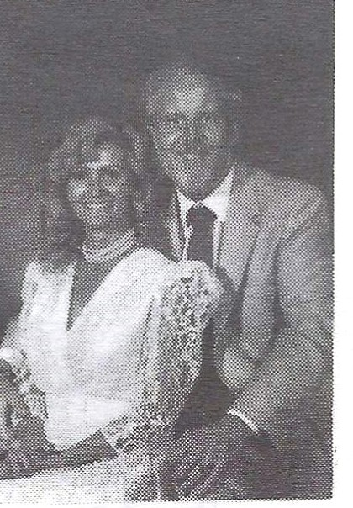

Greg Hobbs (Trish)
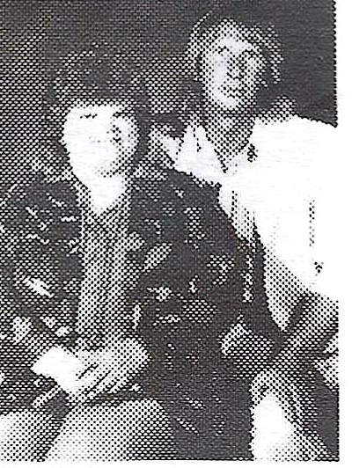

Vicki Heath (Jim)
Kathi Hansen (Jim)
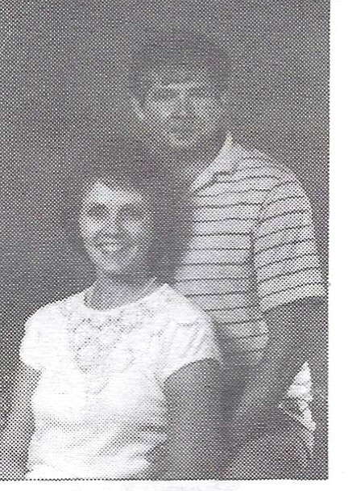

Judy Harris (Al)
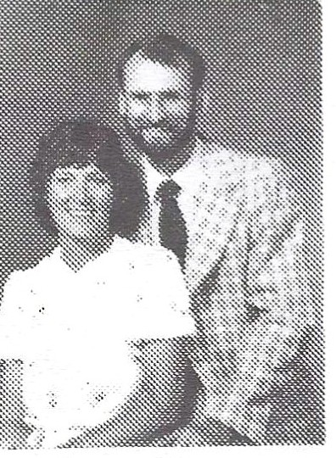

Susan Harter Greg Rice
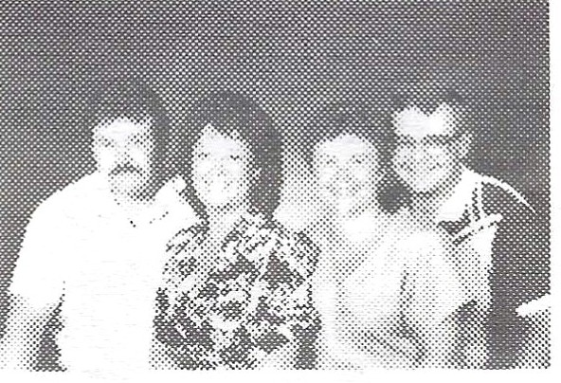

Peggy Jacobsen (Daryl) Chris Burton (Dean)
Sherry Groves Dick Haigh
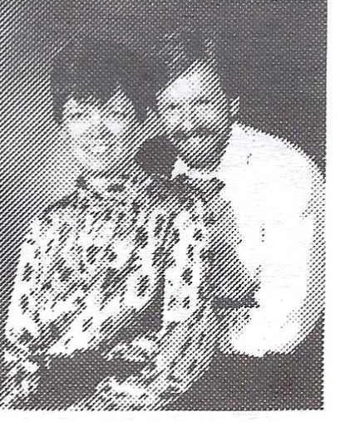

J.ohn Hastings (Charlotte)

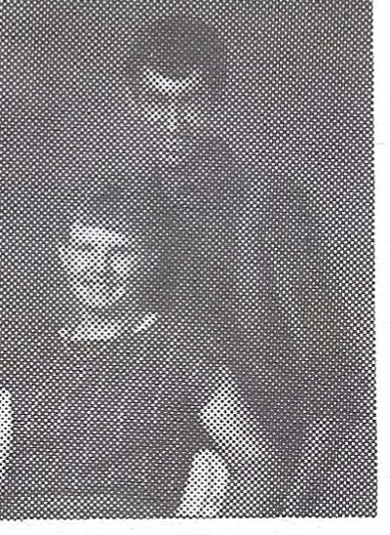

Steven Horning (Carolyn)

Carol Hastings (Gary)
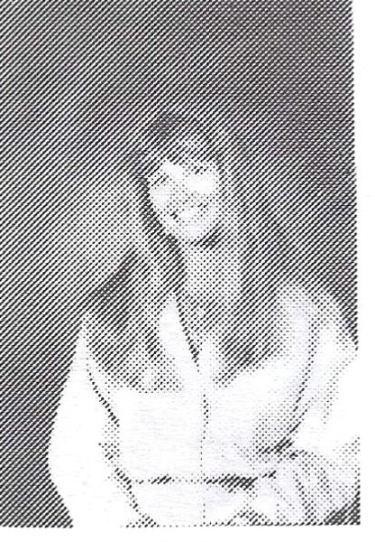

Nicki Jack

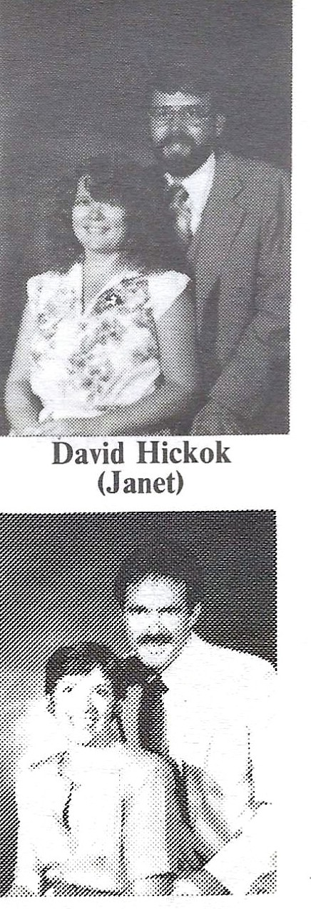
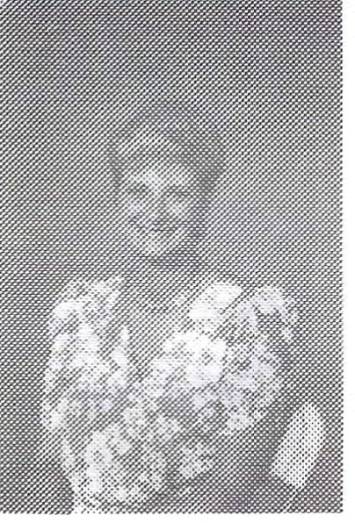
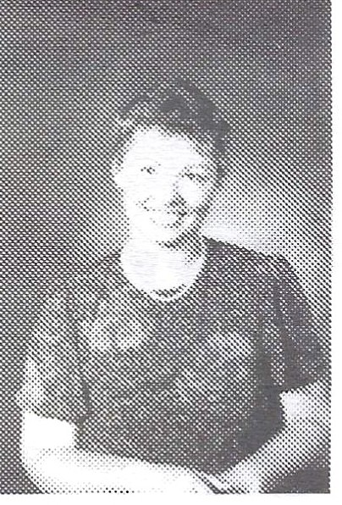
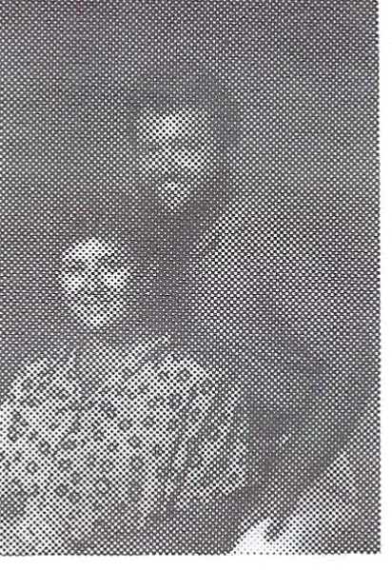
Ginger Jay Judy Jensen Gordon Jesmer (Ann Marie)

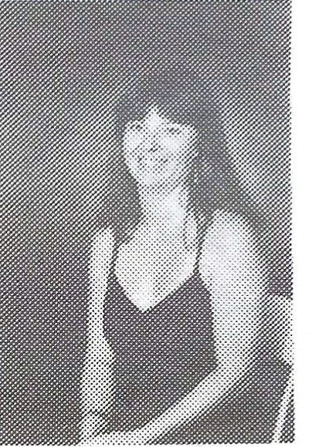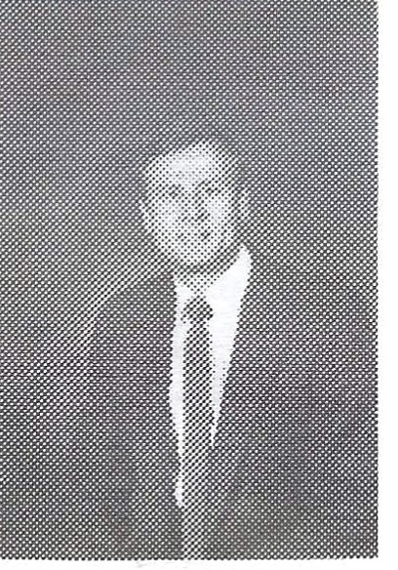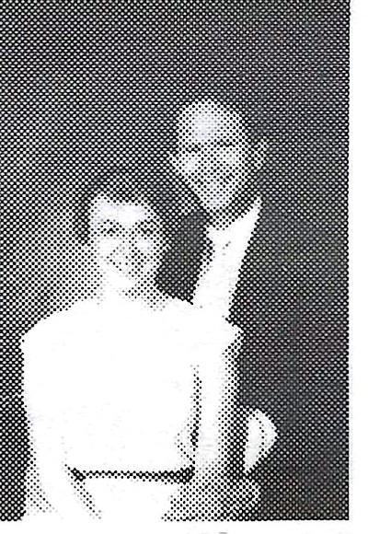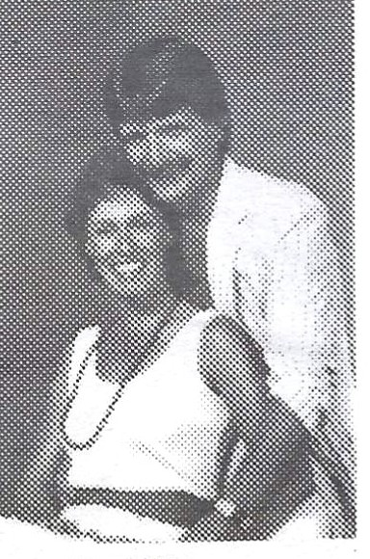

Pan Joramo
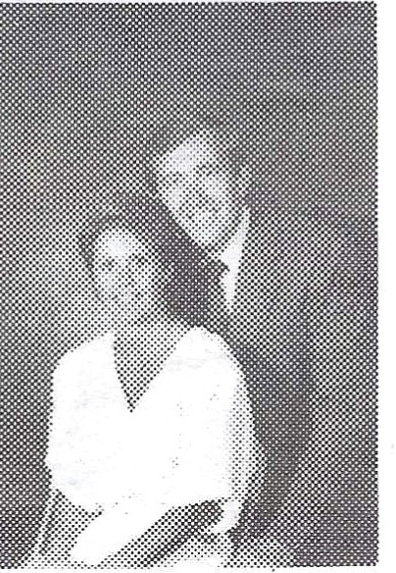

Joyce Kolle (Bill)
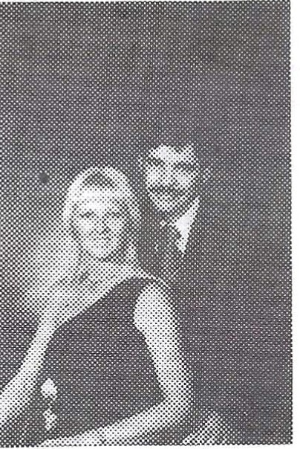

Art Lindsay (Gale)
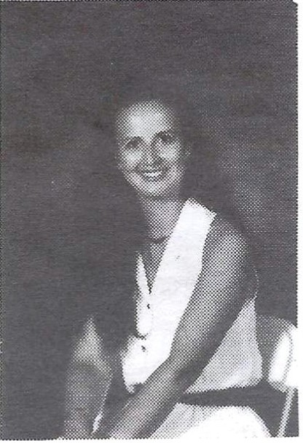

Patty McCormick
Steve Keller
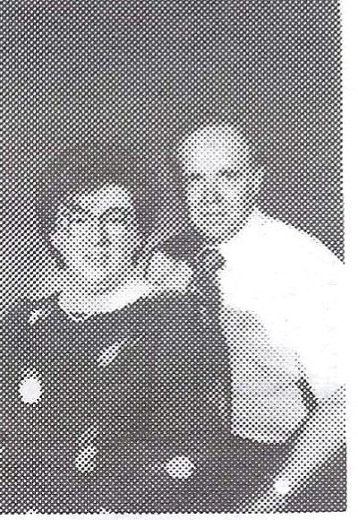

Maxine Kopanski (Stan)
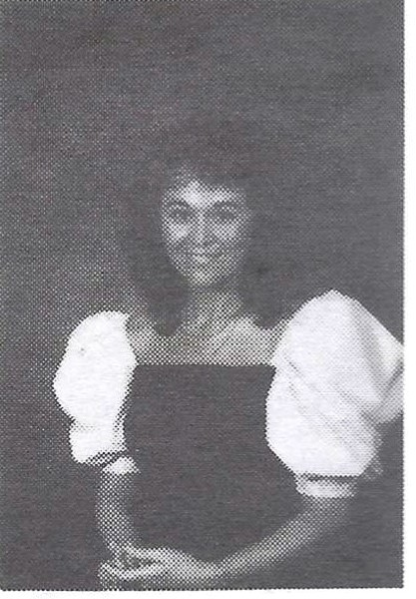

Lois Manley
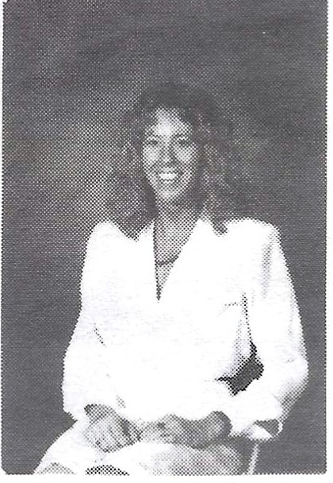

Marcia Merklinghaus
Mary Kerr (Ed)
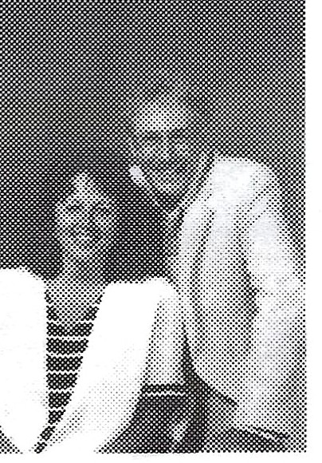

Sheryl Krizan (Darryl)
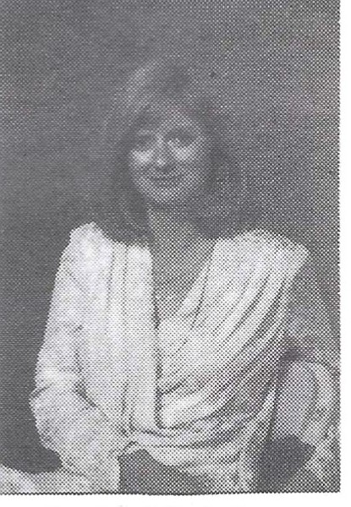

Susan McAdams
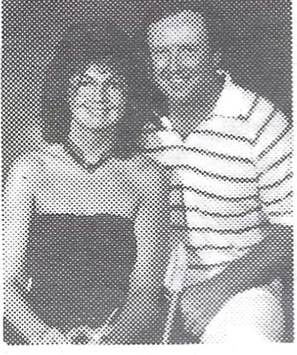

Dave Meyers (Erin)
Sue Knouse (Ron)
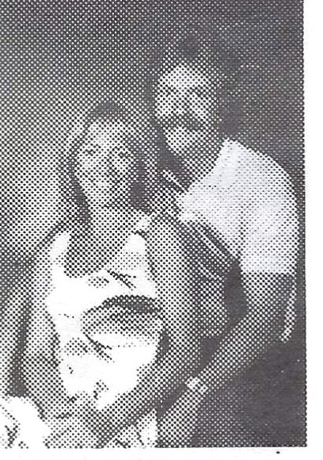

Dave Lewis (Teri)
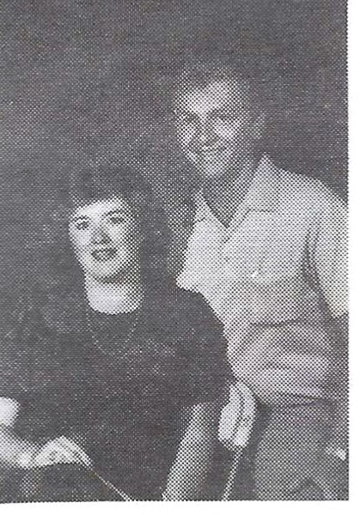

Jim McCann (Lorrie)
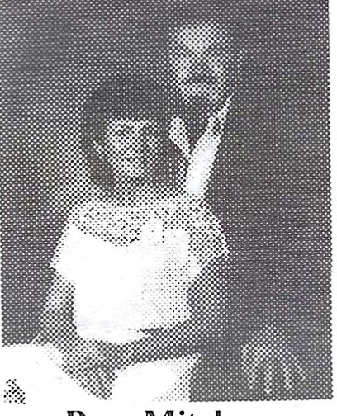

Pam Mitcham (Paul)

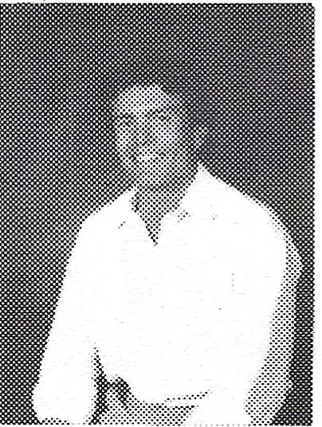

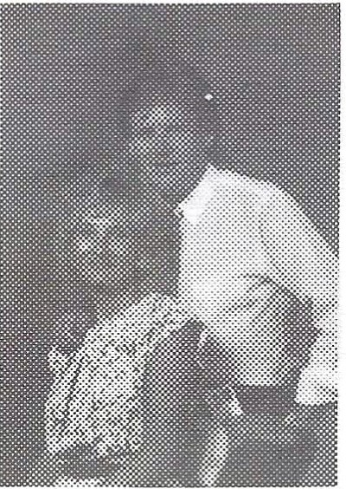
Mike Monnahan
Bill Munson (Jan)

Mark Nicodemus Julie Slocum •
John Nickell

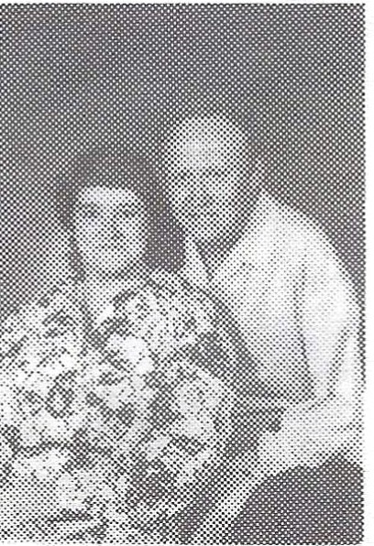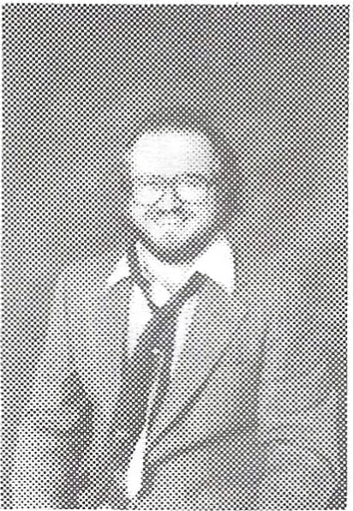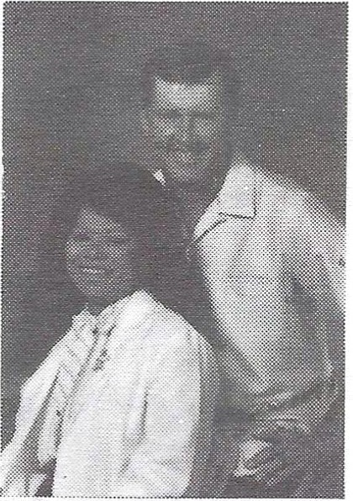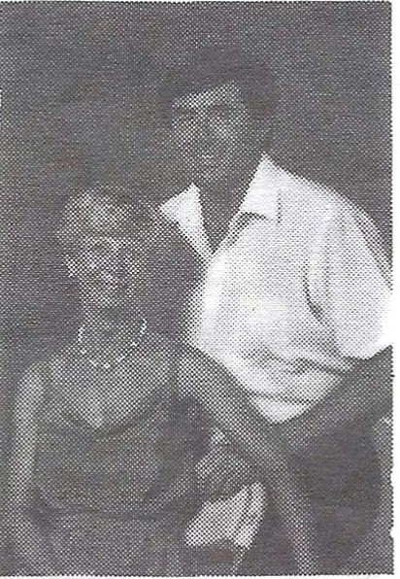

Ken Novak (Lorraine)
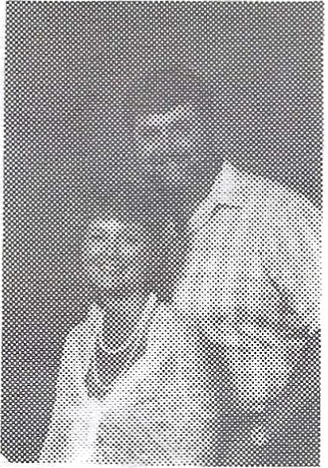

Jerry Pate (Robin)
Greg Olson Larry Paulson (Laura)
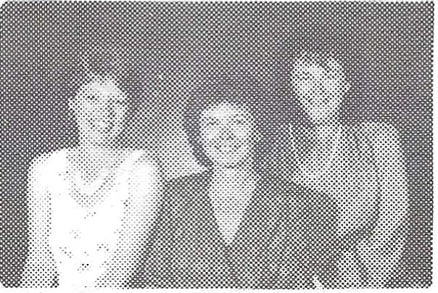
Robin Pittis
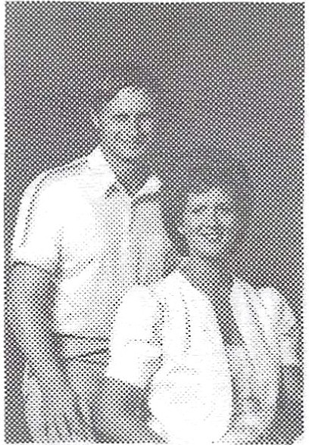
Kari Esterberg Barb Emel

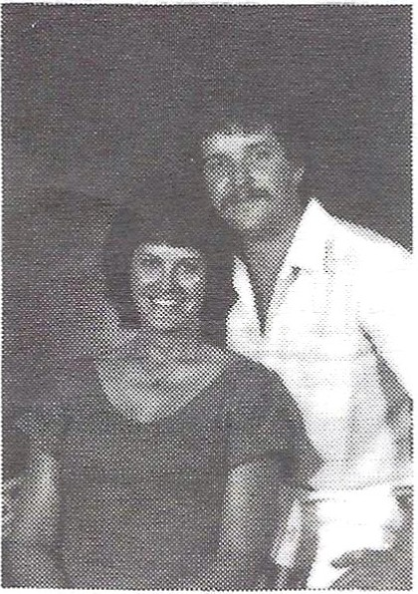
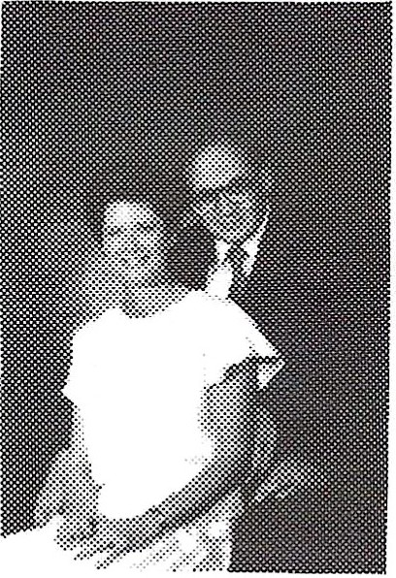
Ray Payne (Sherry)
Linda Pearson (Mark)
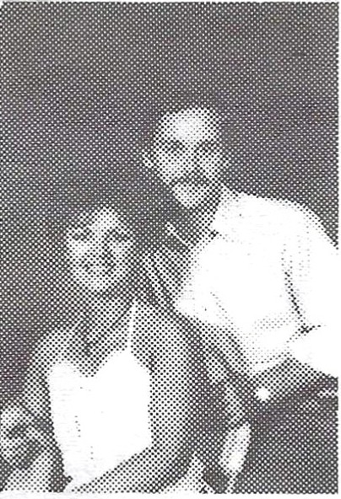

Geri Ritchey (Ray)

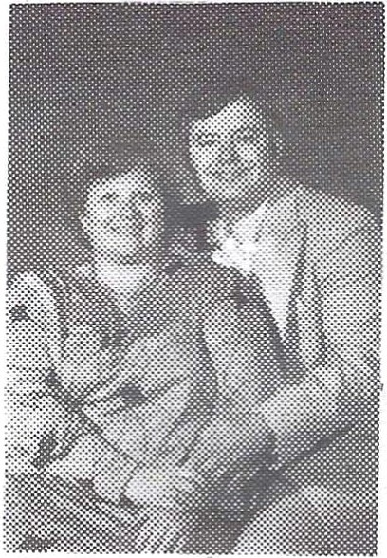

Sharon Reuter
(Bill)

Lois Schultz (Jack)
Pam Sisson (Jim)

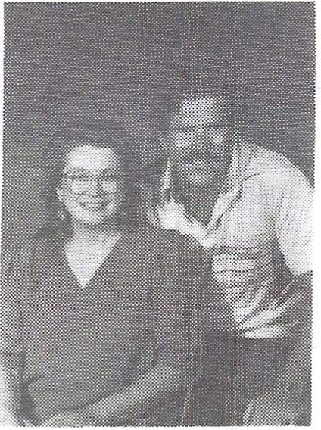
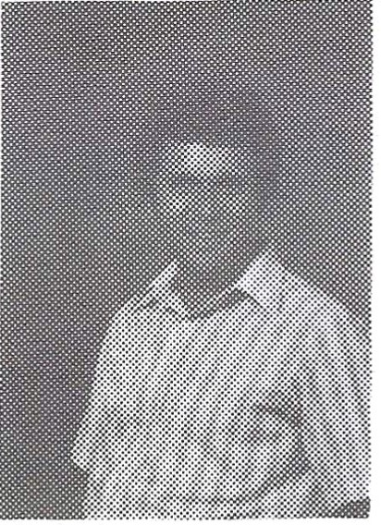
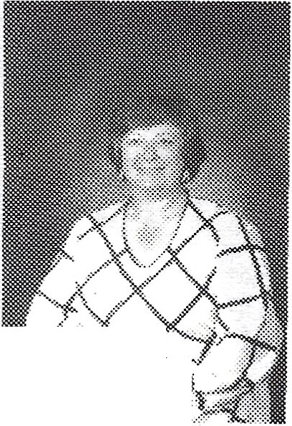
ti
Barbara Sparks

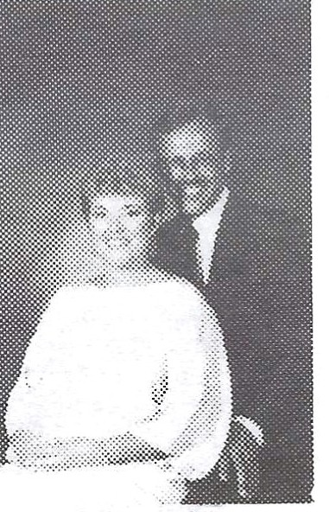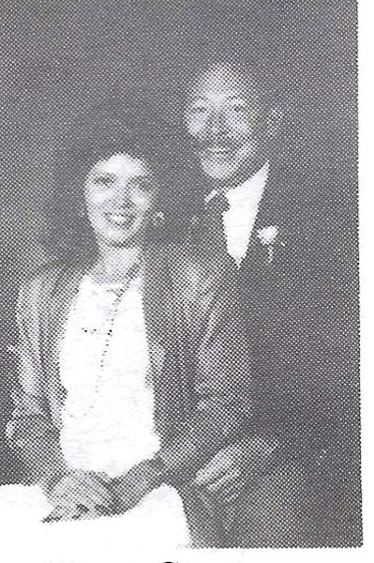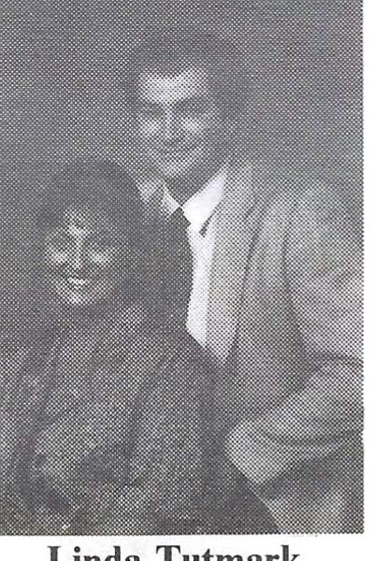

Bonnie Stathem (Ken)
'
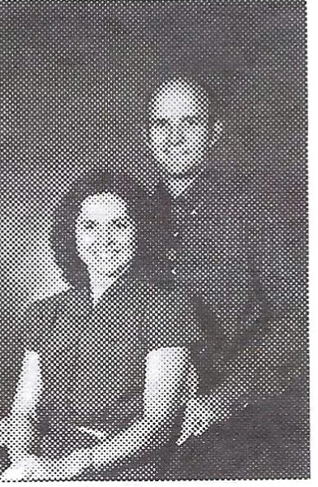

Don Thompson (Susan)
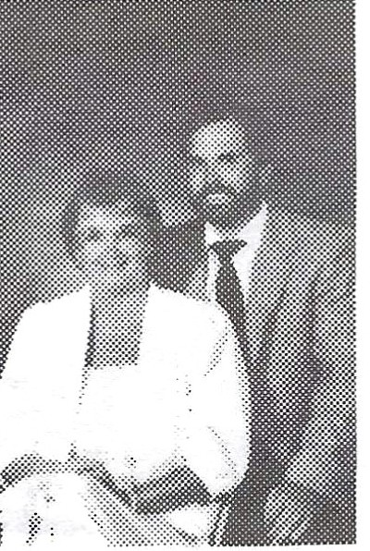

Gene Walters (Marilyn)
Diana Staats (David)
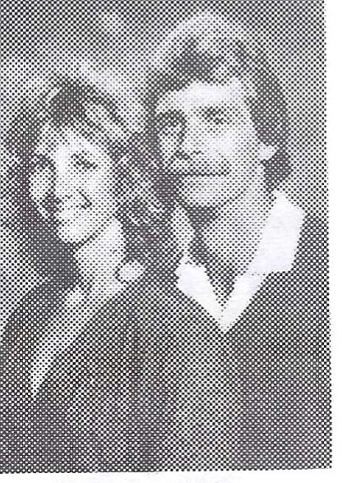

Dennis Tibke (Claudia)
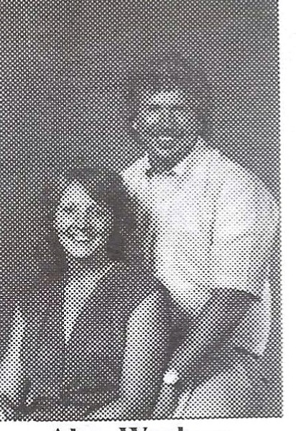

Alan Warberg (Audrey)
Stan Stebing (Sherry)
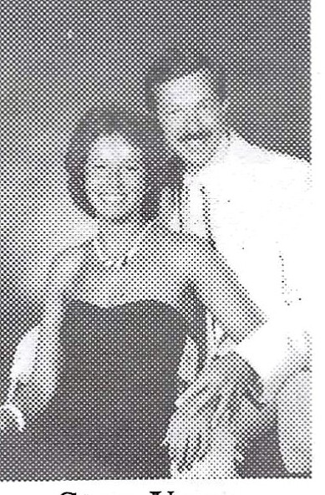

Steve Uram (Carolyn)
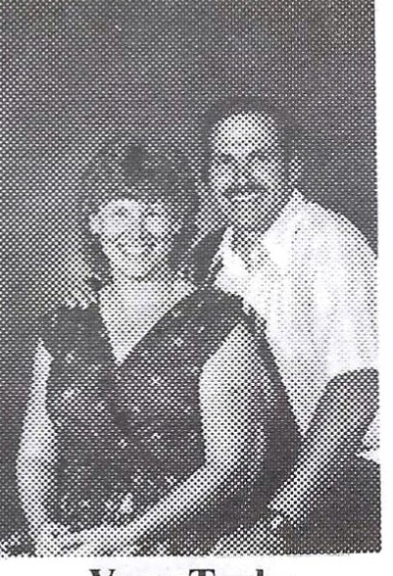

Vern Taylor Linda Wheeler
Linda Tutmark (Tom)
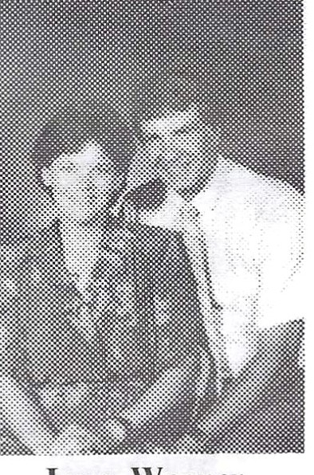

Lynn Wagner (Bob)
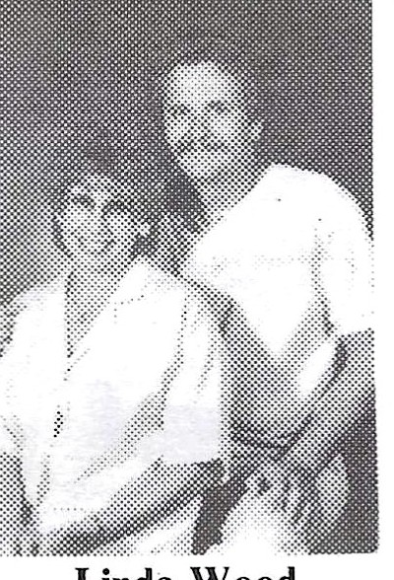

Linda Wood (Bruce)

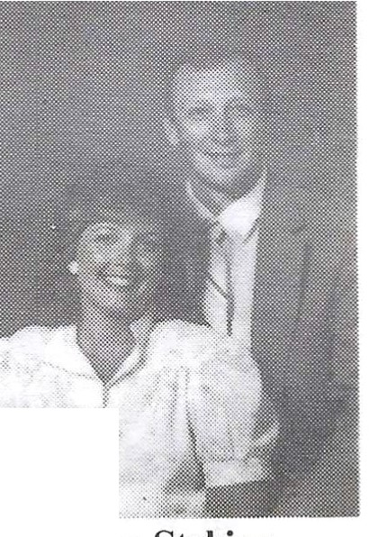
Ii
i •
,r· ,
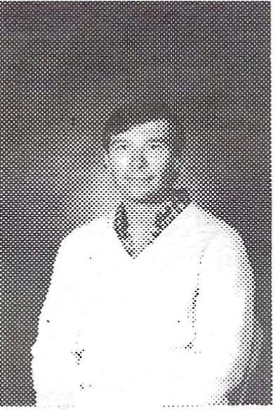
�.

David Zehrung

FOREIGN EXCHANGE STUDENT
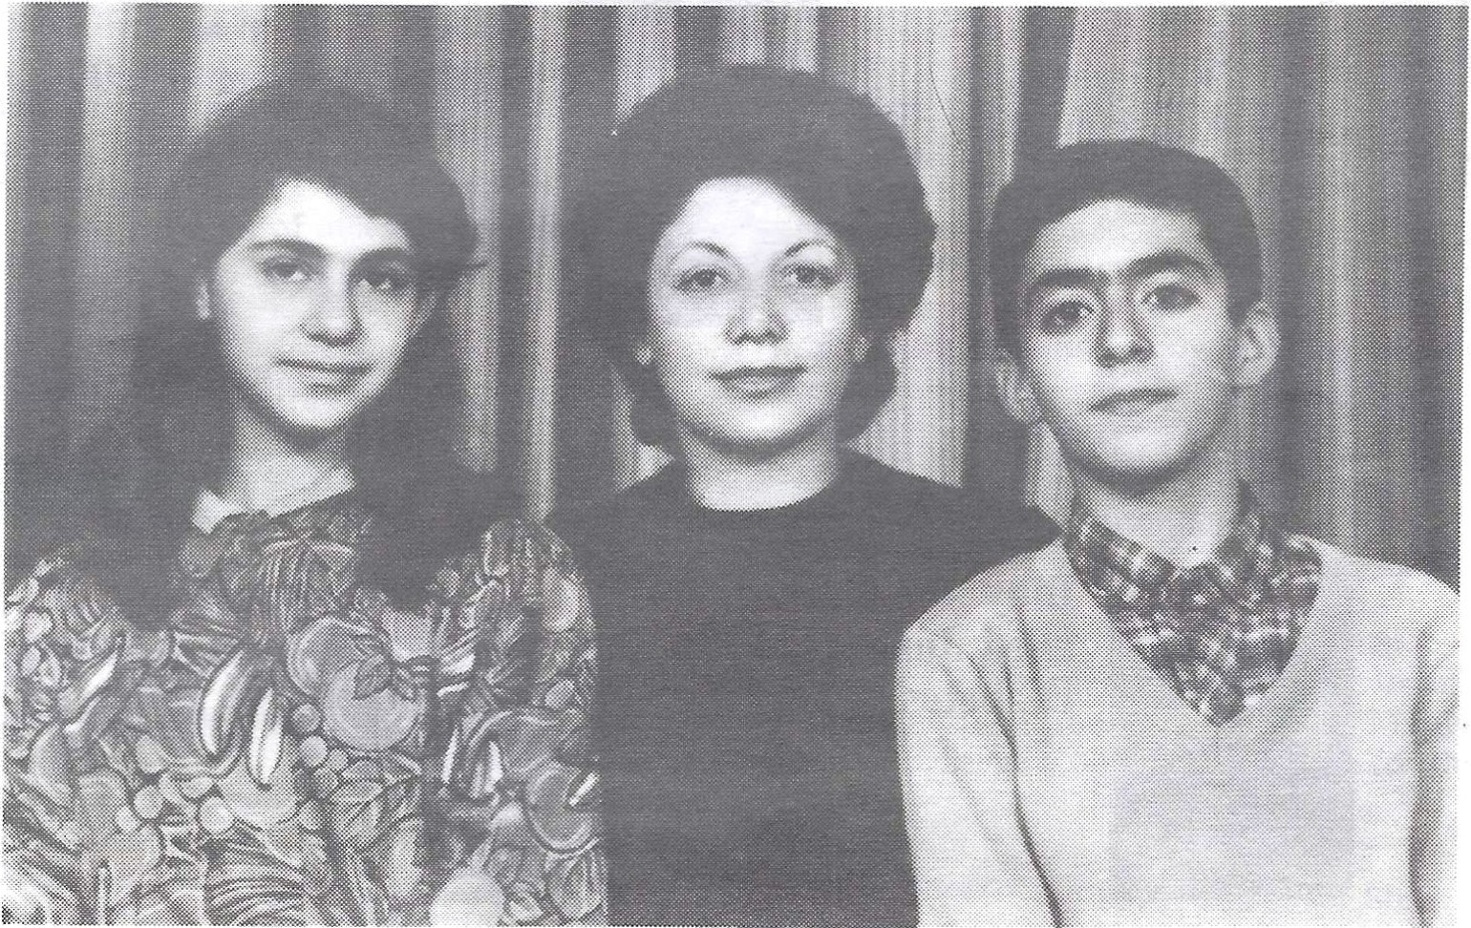
For the first time I'm looking back and trying to see what I have done during these 20 years - the best years of our lives.
After I left Seattle (in tears) I toured the Northern states of America for a month with other foreign students. This has been the best experience of my life. I had to at-tend high school one more year in Cyprus and in 1967 I came to Turkey. I studied Social Sciences in Middle East Technical University in Ankara - the capital city of Turkey. In my last year I got married. My husband is also from Cyprus, we met at the university. He is an electrical engineer. I then continued my education in the field of Education and got a master degree in Program Development & Testing in 1974. In the same year my daughter, Betil, was born. In 1975, my son, Altar, followed. Then I started my years as a mother and housewife. When the children started elementary school in 1980 and 1981 respectively I started looking for a suitable job. Between the years of 1980-1982 I tried to establish a business; private kindergarten. Soon I realized that I could never become a business person since I didn't care much about money. In 1982 I started my present job in the Middle East Technical Univer-sity which I enjoy very much. I'm working at the Prep School as an English teacher now. I earn little but I get great satisfaction from dealing with young people. I in-tend to continue for another 5 or 6 years and then I'll reconsider my life again. With the children at ages 17 & 18 it is easier to do the necessary changes in one's life which it is difficult to do when they are much younger.
Please give my best wishes and love to all the friends who will attend the reunion. If I could I would come with great happiness. Even if I can't make it please let our friends know that I'll be thinking of all of you on that day. My stay there was one of my happiest years of all my life. The memories are still very fresh and I think it will be so as long as I live.

With best wishes and love, Balkas Teoman Eroz
Turgut Reis Cad. 33/F Tandagan - Ankara, Turkey

OUR DECEASED CLASSMATES

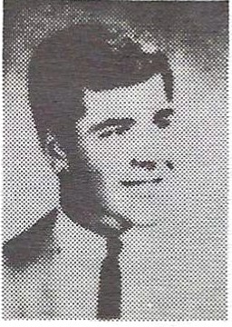
Cary Cox Died 1970 Auto Accident
Robert Killien
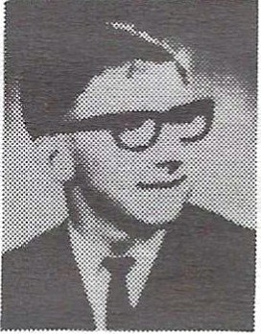
Died September 6, 1979 Cancer

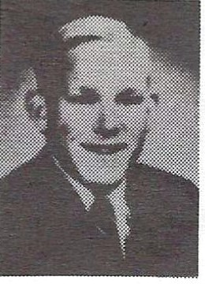
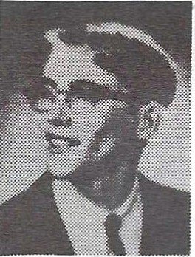
Billy Joe Carter Died June 22, 1986 Diabetes
Michael Koch Auto Accident

After the clouds, the sunshine After the winter, the spring After the shower, the rainbow,
For Life
is a changeable thing; After the night, the morning
Bidding all darkness to cease
After Life's cares and sorrows, the comfort
And sweetness of Peace.
- Helen Steiner Rice

Alton W. Akers
9233 36th Avenue S.E. Everett, WA 98204
(206) 337-6688
Spouse: Marti Ann Children: Cabe, age 8; Cailyn, age 6½
Bio: Have had my own custom cabinet business since 1977. Also manufacture small custom trailers for motorcycles and im-port cars. In 1985 I began general contracting.
Took my '56 for an 8,000 mile trip in 1981 to tour New England and northern U.S. I've also put a lot of miles on my Hondas on various rides and trips.

Billie M. Alguard
2942 West Lake Sammamish N.E.
Redmond, WA 98052
(206) 885-6537
From December 25-April 1:
P.O. Box 4619 • Ketchem, ID 83340 • (208) 726-3013
Spouse: James L. "Len" Evans
Children: stepsons: Mike, age 25; Scott, age 24; David, age 21.
Children: Kristi, age 10; Jeff, age 9
Bio: Attended University of Washington for two years. Graduated from Shoreline Community College as a dental hygienist in I 970. Worked in private practice in Seattle area for five years. Taught clinical dental hygiene at SCC for four years. Happily married since 1972. Raised three stepsons. Adopted two infants, now 9 and IO. Became a born-again Christian in
1977. Traveled to Israel, Africa and the Carribean.
Teach a class called "Homemaking as an Organized Profes-sion." Divide time between residences on Lake Sammamish and Sun Valley, Idaho.

Robert Aline, Jr.
544 Front Street South # Issaquah, WA 98027
(206) 337-6688
Spouse: Rosemary
Children: Kristin, age 3½; Marian, age 1
Bio: Attended University of Washington for four years, then went to graduate school at the University of Wisconsin. Obtained a Ph.D. in biochemistry in 1975. Since then have worked in Van-couver B.C., San Diego, and Issaquah.
Met Rosemary while in San Diego; married in 1981. Moved to Issaquah in 1983 and work for the Issaquah Health Research In-stitute as a molecular parasitologist.

Lucille Alkire
34605 46th Avenue South Auburn, WA 98001
(206) 838-5997
Spouse: Lee Haarstick Children: Tom, age 8; Cari Lynn, age 5½
Bio: I retired after twelve years as an X-ray technician to have our son, Tom. Hence a new career. Cari blessed us 2½ years later-more new career. So now I'm quite busy with carpools, homework, soccer, ball games, tumbling, helping at school, etc. We enjoy traveling, biking, swimming, et al. Especially travel-ing to Disneyland, so all the kids can have fun (specifically Lee and me!). Our life is full and may God bless your life as he has ours. Have fun at the reunion-we will be vacationing at Sun
River.

Richard Anderson
22303 51st Avenue West Mountlake Terrace, WA 98043
(206) 774-2040
Spouse: Karen
Children: Richard, age 17; Steven, age 15
Bio: After graduation I went into the Army for two years, and as most of us did, I spent time in Viet Nam. When I got back to the States, I got married.
I then went back to school for four years to become a journeyman carpenter. I am now a general contractor with my specialty being custom homes.
My most important job, however, is being the father of two wonderful boys. I now know what my parents were going through twenty years ago!

Tom Anderson
19924 80th Avenue S.E. Snohomish, WA 98290
(206) 668-2878
Spouse: Marilyn
Children: Carrie, age 9; Brian, age 5
Bio: I'm still at the "lumberyard." Marilyn has been teaching math at Bellevue Community College for the past six years.

Vicki Arnold
114 East Palmer Street Sequim, WA 98382
(206) 683-3888
Spouse: Del Caryl Children: Jesse, age 11; Ryan, age 6
Bio: The first ten years after school, we were farming in Snohomish, with my husband employed by the county fire department. After the birth of our first son, we moved to the "sunbelt" of Washington-Sequim.
We are owners of Bandit's Pizza Parlor in Sequim, which has kept us active in the community. Since the birth of our second son, I have been working as a preschool teacher and love it!

Dave Aspnes
1227-A 164th Street S.W.
Lynnwood, WA 98036
(206) 745-0857
Spouse: none
Children: Terra, age 7; Brian, age 12
Bio: I've been teaching school for the past fourteen years. Lots of travel over the United States, Mexico, Hawaii.

Alicia Austin
18101 80th N.E.
Bothell, WA 98011
(206) 483-1387
Spouse: Ralph Nachtigal
Children: Mike, age 20; Doug, age 17; Paula, age 10.

Becky Backes
1040 C Avenue
Edmonds, WA 98020
(206) 778-7706; 771-4247
Spouse: Richard T. Muir
Children: Heather, age 14; Megan, age 10; Mitchell, age I
Bio: Married Rick Muir in 1982 and traveled to Asia and In-donesia for one month. Rick is national sales manager for a large seafood company and has helped me build my own business!

Helen Beckman
5602 Camelot Drive S.W. Olympia, WA 98502
(206) 352-0532
Children: Lisa, age 16; Jeff, age 12
- Bio: Bernie and I have been married almost nineteen years (must be a record in this day and age!). I am secretary to the Director of the Special Education Division, State Department of Education, in Olympia. Bernie works at an engineering/construc-tion firm.
I caught the "exercise bug," so am now "aerobicizing" and running three miles after work (when I have time!). My family en-joys snow-skiing (took a vacation to Sun Valley in April); water-skiing; camping (we have a river lot on the Skykomish River); and the kids are in sports activities (Jeff wants to be on the Seahawks team some day). We just purchased a 1966 Mustang for Lisa-that was a very good year!
Also, thank you to all the Reunion Committee for making this event happen! Where did twenty years go?

Jim Bilder
Box 1668
Lynnwood, WA 98046
(206) 743-6529
Bio: Associate degree in photographic illustration. Freelanced; worked as cop.tractor, developer, writer. Lived in New York, California, Alaska. Missed the rain and moved back here. Started flying recently.

Dick Birkenbuel
1307 130th Street N.E. Everett, WA 98204
(206) 337-0387
Spouse: Susan
Children: Zack, age 9; Darin, age 1½

Burgenia "Genny" Blackford (Hall)
3720 104th Place S.E. Everett, WA 98204
(206) 337-4064
Children: Angela Hall, age 15; Jessica Hall, 12

Melvin A. Bowman
1106 North 46th
Seattle, WA 98103
(206) 547-3474

Katherine Bone (Chipman)
6034 S.E. 36th
Portland, OR 97202
(503) 771-4263
Spouse: none
Children: Annie, age 6; Tyler, age 4

Kevin Brechner
253 South Rosemead Boulevard Pasadena, CA 91107
(818) 304-0080
Spouse: none Children: none
Bio: Since college, I taught school for about five years. Now I work for a company that transports artwork for museums, and I have a business devoted to motion picture production. I've been doing a lot of writing lately. My main hobby is painting.
I still live in the Los Angeles area and am still breathing the smog, although I'm beginning to believe smog is good for you. It provides nutrients not otherwise available through food.

Sherri Briggs (Sant)
3780 Foothill Road Santa Barbara, CA 93105
Bio: I have had a wonderful past twenty years. I have lived each
year in Australia, Mexico and Japan. I have just received a BS in Business Management as well as a two-year degree in interna-tional business.
I now live in Santa Barbara, California. I attended our MHS
ten-year reunion, am here at our twenty-year reunion, and I look forward to seeing everyone again at our thirty-year reunion.

Barbara Brown
(See Bob Christopher)

Dennis E. Brown
5829 150th Place S.W.
Edmonds, WA 98020
(206) 745-6227

Sharon L. Burfitt
S.E. 2632 Arcadia Road Shelton, WA
(206) 426-9939
Spouse: John N. Johnsen
Children: Ryan, age 13; Michael, age 9; Chad, age 8
Bio: It seems incredible that twenty years have passed so quick-ly. I enjoyed the priviledge of staying at home a long time with my children and doing licensed daycare in my home. Now that my children are older I'm enjoying being a doctor's assistant here in Shelton.
We love the Shelton area and the private surroundings we live
in. I am an advocate for Recovery (domestic violence and sexual assault). I'm a Den Leader once again for my two youngest sons. As of April my oldest turned 13, so now we join the rest of you who have a teenager in the house. So far, so good. (Oh, but the stories I've heard!).
Happy 20th to all of you!

Sandy Boone Star Rt., Box 44B Pateros, WA 98846
(509) 923-2834
Spouse: Richard Nelson Children: none
Bio: I am the librarian for the small town of Bridgeport, and my husband of seventeen years is still employed by Washington State Parks Department. We live in a beatiful setting at Alta Lake out of Pateros.
Chris Burton
9640 161st Avenue N.E. Redmond, WA 98052
(206) 885-3240
Spouse: Dean Stensby
Children: Toni, age 16; Rene, age 14; Tim, age 11
Bio: After graduation, I attended the Lynnwood Beauty Col-lege and received my beautician's license. I married in 1967, and worked for a short time. We started a family and moved to Red-mond in 1972. Have been busy with children and family since.

Michael Burton 31041 9th Avenue South Federal Way, WA 98003
(206) 839-9201
Spouse: Susan Children: Christopher, age 11
Bio: 1966-1967: Attended Everett Community College. 1967-1970: Served in Viet Nam with the U.S. Army.
1970-1980: Married; had one son; worked my way through the University of Washington; graduated in 1978. Worked five years as a stockbroker for Bach, Halsey, Stuart in Seattle.
1980-present: Divorced; returned to the Army; served two years with the 82nd Airborne Division, Fort Bragg, North Carolina. Served two years in Germany; traveled all over Europe. Returned to Fort Lewis, Washington, in 1984. Married Susan in 1985. Cur-rently serving with the 1st Special Forces Group.

Bruce P. Byers
22318 17th Place West Bothell, WA 98021
(206) 481-4193
Spouse: Patsy Children: none

Marie Cameron
5930 140th S.W.
Edmonds, WA 98020
(206) 745-1515
Spouse: Mike Hodges Children: Danielle, age 17; Phil, age 13
Bio: Mike and I have been together the last eighteen years; we still live in the area.

Frank Carter
825 153rd Place S.W. Lynnwood, WA 98037
(206) 745-3486
Spouse: Melissa
Children: Jennifer, age 11; Nathan, age 5; Emily, age 3; Caroline, age 2
Bio: Working as programmer/analyst for Intermec Corpora-
tion in Lynnwood. Since MHS, have served in Army overseas, completed master's degree in education at Oregon State Universi-ty. Currently a doctoral candidate at O.S.U. Busy raising a fami-ly. Hobbies: hiking and camping.

Van M. Caryl 15604 75th Place West Edmonds, WA 98020
(206) 743-0669
Spouse: none Children: none

Linda Christenson
3002 Red Cedar Place South
Mill Creek, WA
(206) 337-7386
Spouse: Darrel Aardahl
Children: Janny, age 12; Becky, age 10; Andy, age 7
Bio: After a year and a half of college, and a brief career at Boeing, I settled down and got married. My husband owns his own business and I do his books.
We keep busy with skiing, jogging, backpacking, and with church activities. We are committed to the Lord and to each other.

Bob Christopher
4218 Chelsea Way
Anchorage, AK 99504
(907) 337-2192
Spouse: Barbara Brown Children: Carrie, age 17; Chad, age 15
Bio: Barb and I have two beautiful teenagers. We spent our first ten years in Seattle, where I was a paramedic for the Seattle Fire Department. We moved to Anchorage in 1979.
I now own Alaska Towing and Wrecking, and Barb works with the Anchorage School District.

Michael J. Clemans 4607 188th Street S. W. Lynnwood, WA 98037 Spouse: Martha
Children: Michale, age 16; Monica, age 15
Bio: I am an operating engineer. I have two wonderful daughters who are both very athletic, and I spend all my free time coaching them. My wife and I celebrated our 18th anniversary in June and recently had a new home built in Lynnwood.

Roger Clement
14106 56th Drive S.E. Everett, WA 98204
(206) 337-3668
Spouse: Nancy
Bio: It took a while to finish with school. After MHS I went to Washington State University. Then I worked at the phone com-pany for a couple of years before returning to graduate school in psychology. I finally completed the Ph.D. in Child Clinical Psychology from the University of Washington in 1982.
For the past four years I have been a psychologist at Fircrest School in Seattle. Nancy and I have been married 7½ years-we enjoy travel and gardening. We don't have any kids-yet!

Susan Coleman
25374 169th Avenue S.E. Kent, WA 98042
(206) 630-4211
Bio: During the past twenty years, I have been pursuing numerous interests, primarily work, and some play. I have been employed at AT&T for the past seventeen years.
I have also done extensive traveling throughout Europe and North Africa taking sociological data on the habits of the North American Gigantua Bigmouthas. I'm still pursuing my ultimate goal of "Lotto Winner" but I'm sorry to report I haven't attained this quite yet.

Jim Conner
3325 Grand Avenue Everett, WA
(206) 252-3344
Spouse: Candice
Children: Jennie, age 16; Nichole, age 5

Bill Cross, Jr.
11901 44th Avenue N.E. Marysville, WA 98270
(206) 659-9353
Spouse: Madeleine Children: Tim, age 16; Tanya, age 12

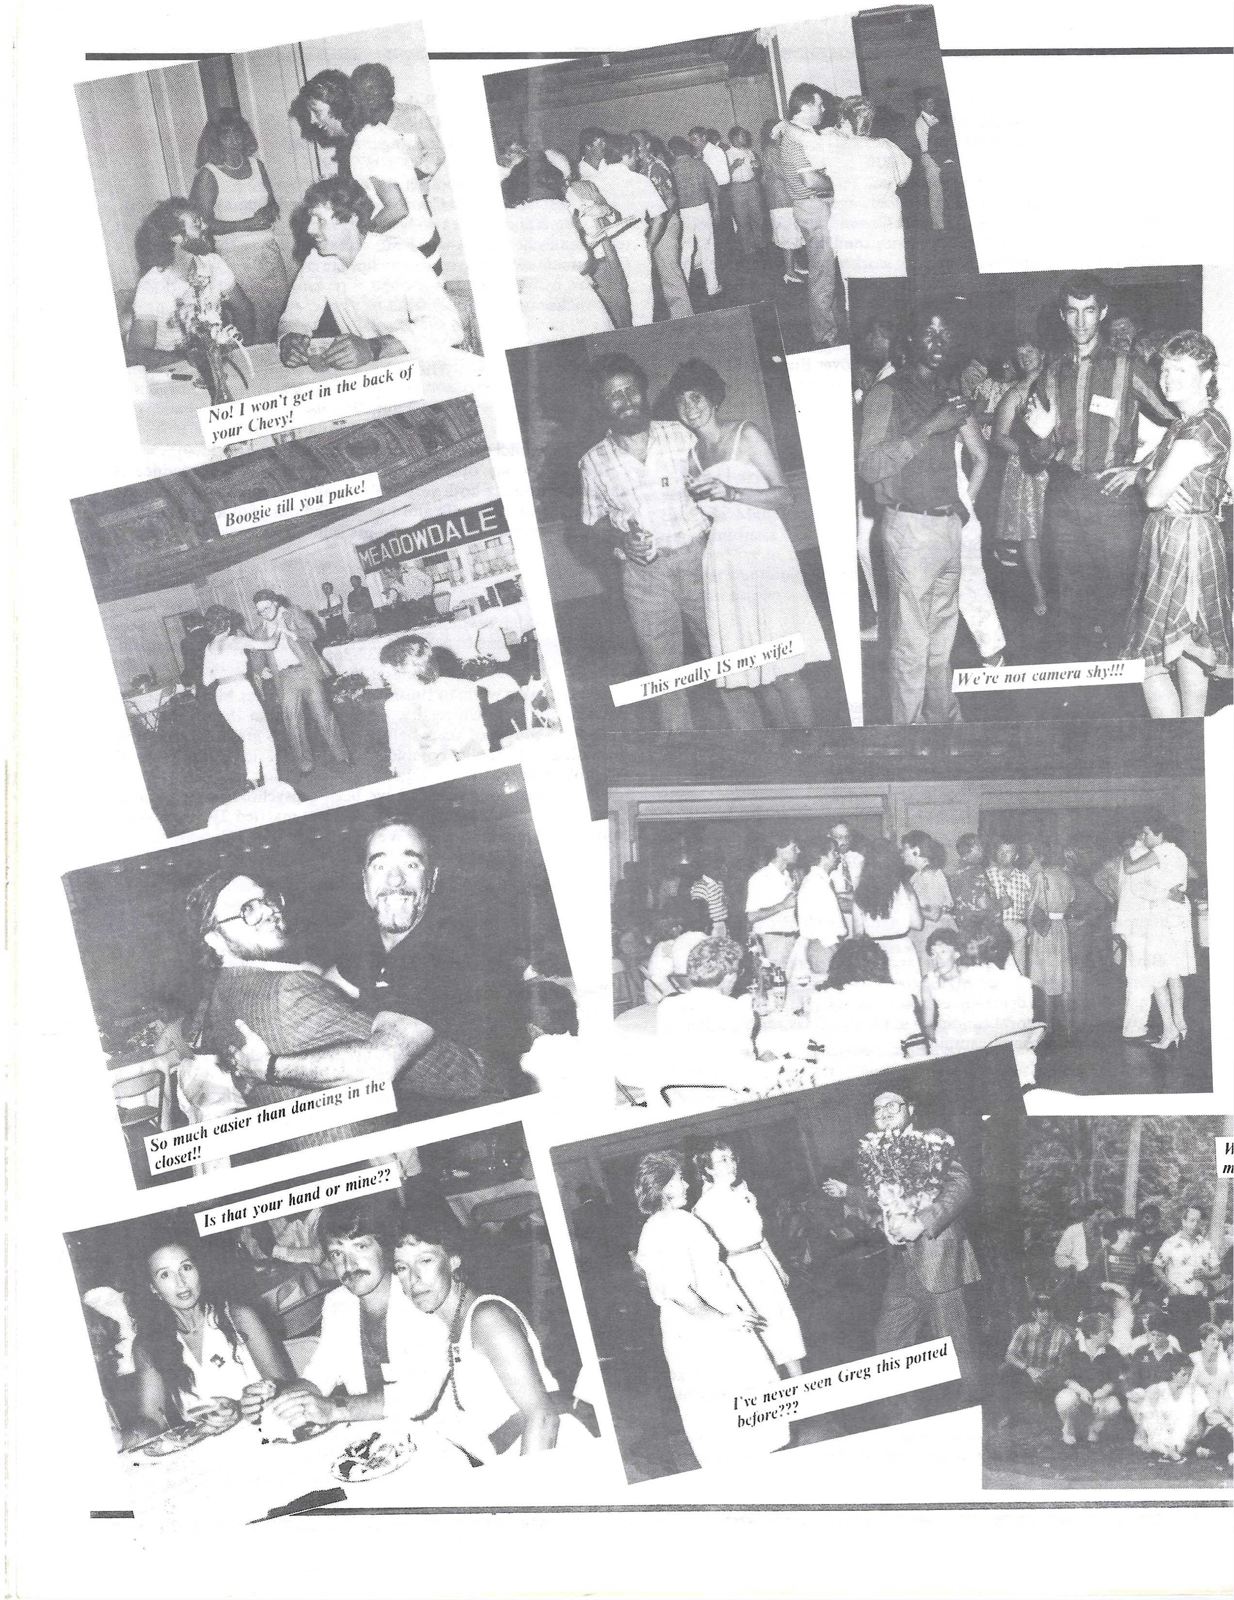

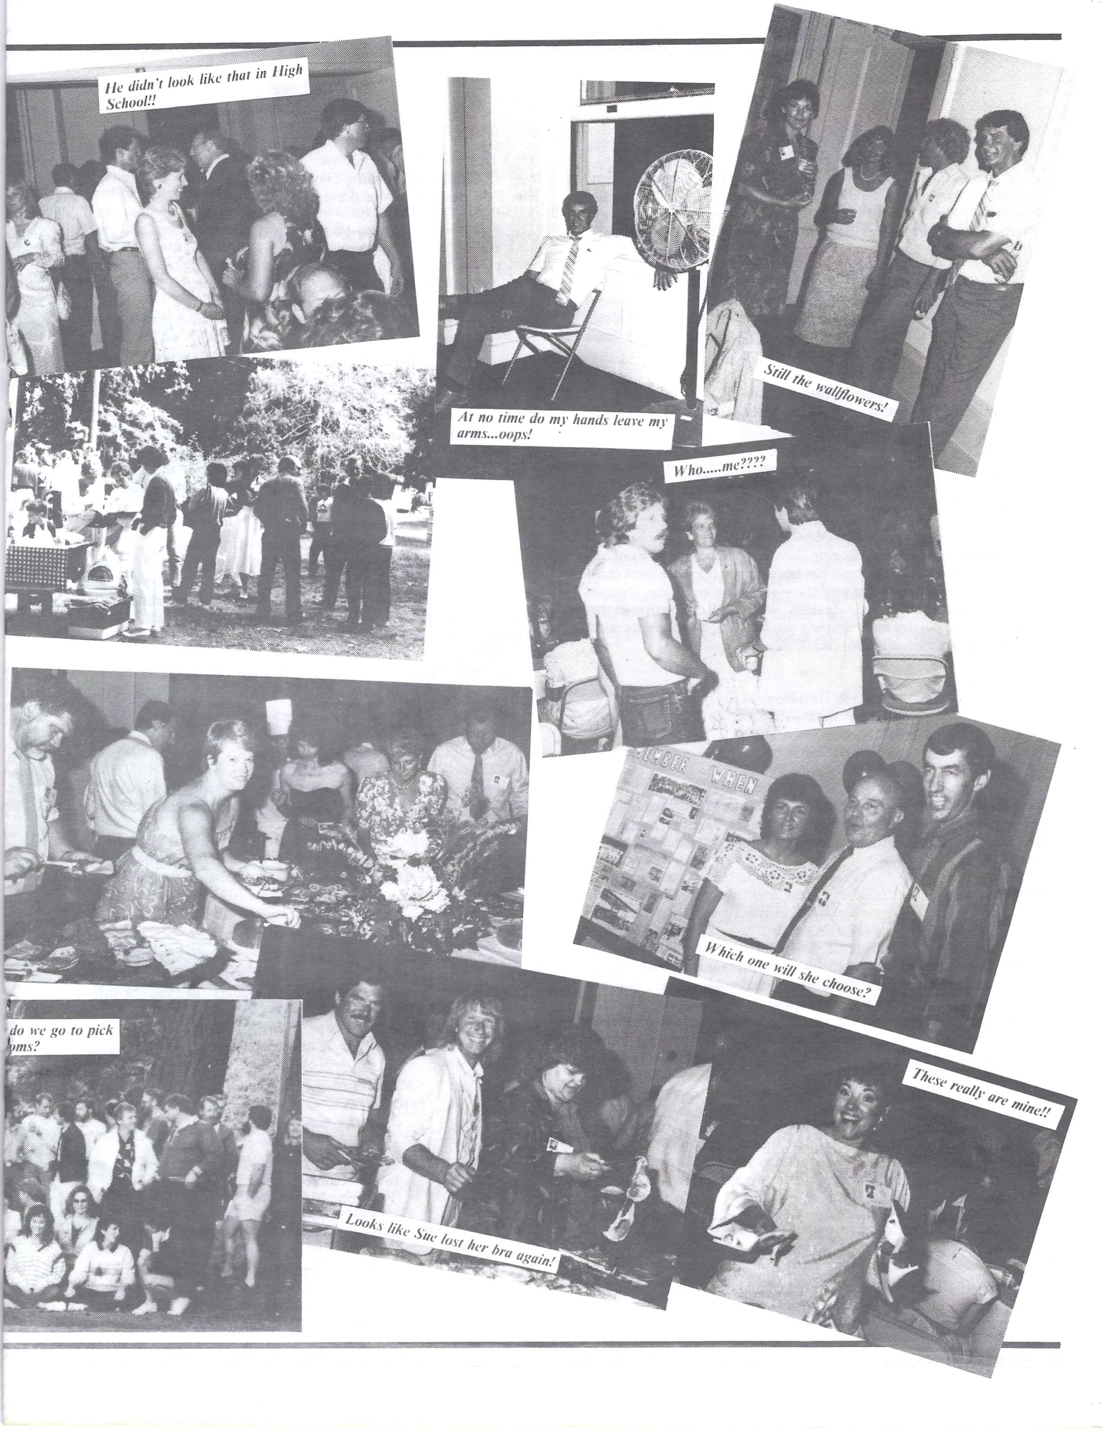

Terry M. Crump 1232 East Pole Road Everson, WA 98247
(206) 354-5855
Spouse: Ginny A. Crump
Bio: Flew helicopters in Viet Nam. Graduated from Western Washington University. Taught school in Australia for a couple of years. Managed a retail store in Bellinham for seven years. Ran a marine facility in Bristol Bay, Alaska, for two years, and cur-rently am a purchasing agent/manager for LFS Inc. in Bell-ingham.

Robyn Dastis
5914 64th Avenue N.E. Marysville, WA 98270
(206) 659-9247
Spouse: Joel Woods
Children: Eric Lee Rindy, age 19½; Melissa Lynn Woods, age 13½

Stephen L. Dauzenroth ("Dauzy")
1109 N.E. 181st Place Seattle, WA 98155
(206) 363-7792
Bio: Inventory planner, Boeing Aerospace Company, Kent.
Whitewater riverraft guiding has been taking up most weekends of late. Into SCUBA, water and snow-skiing on occasion. Recent travels to Australia and New Zealans, with most of Europe in the past. Dancing, parties and camping are fun too. Seek female with some like interests; call (206) 363-7792.

Jack Davidson
14131 92nd Street S.E. Snohomish, WA 98290
(206) 568-9021
Spouse: Cecile Ferrill Children: Jeff, age 14; Rob, age 12
Bio: B.A., College of Forestry, University of Washington. Recreation Supervisor for Snohomish County Parks Department, eleven years. Snohomish resident. Raise show and beef Black Angus cattle.

Ken Davis
6319 168th S.W.
Lynnwood, WA 98037
Bio: Have my own business, doing well. Have two children: a girl, 14, and a boy, 8. Still live in the Meadowdale area. Do a lot of sailing, fishing, and try to enjoy life.

Greg Delamarter
12809 S.E. 22nd Pl.
Bellevue, WA 98005
(206) 644-4496
Spouse: Lucia
Children: Jeremy, age 11; Christopher, age 8
Bio: BS in mathematics from Seattle Pacific. Traveled with Continental Singers and Orchestra for two summers.
Married Lucia in June, 1971. Worked as a youth minister in Bellevue, part-time. Employed by Williman & Robertson in Oc-tober, 1970. Traveled to Orient in 1982 with a gospel quartet, as pianist. In 1984, completed exams for fellowship in the Society of Actuaries.
Currently, I am an Actuary with Milliman & Robertson (con-sulting Actuaries, specializing in pensions). Piano and keyboards for the Eastside Quartet. Reside in Bellevue.

Steve De Long
16703 Dubuque
Snohomish, WA 98290
(206) 334-5848
Spouse: Bea
Children: Dawning Day De Long, age 15½
Bio: You name it, we've done it.
Tony Di Pangrazio 16729 North Road Lynnwood, WA
(206) 743-2250
Bio: Construction, crab fishing, logging, real estate.

Linda Dodge (Lux)
10725 127th Avenue N.E. Kirkland, WA 98033
(206) 827-7475
Bio: I'm a single parent with three children: David, age 13, Sharilyn, age 11, and Kathleen, whom we lost last year due to a congenital heart defect.
I'm a junior majoring in speech communication at the Univer-sity of Washington. I hope to eventually land a teaching job.

Rick Doty
24324 Miller Road Stanwood, WA
(206) 629-2978
Bio: Army-three years; real estate sales-seven years; real estate broker-eight years; general contractor-two years.
Significant events: birth of daughter Dina, age 15. Marriage to wife Diane in 1976. Born again-accepted Jesus as Lord and Saviour, 1980. Birth of adopted son Nathan Chandler, 1986.

Jean Elvin (Christ)
605 Colby Circle #4
Claremont, CA 91711
(714) 621-1033
Children: Jill, age 19; lives on the Island of Kauai in Hawaii
Bio: Currently enjoying life, appraising reai estate in southern California.

Pat Echelbarger &
Marilyn Miller
P.O. Box I
Lynnwood, WA 98046
(206) 363-7792
Bio: We have been married 17 years. Pat taught school for 4 years in Central Kitsap School District. He is now a land developer and builds commercial buildings in the South Snohomish County area.
Marilyn is an R.N. and works part time for a local cardiologist.
We have two sons, Andy, age 7; and Matt, age 11.

Joan Elvin
14101 Aurora Avenue North Seattle, WA 98033

Barbara Emel
16795 Seminole Road
Poulsbo, WA 98370
(206) 779-6258
Spouse: Dean H. Dale
Children: Katherine Medora Dale, age 7 months
Bio: I have been teaching learning-disabled students in the Tacoma Public School for the past twelve years. My husband, Dean, and I took a year off and sailed to Tahiti via Alaska and Mexico before our daughter, Katie, was born.

Kari Esterberg
720 Spruce Street
Edmonds, WA 98020
(206) 774-3903
Bio: I live happily and peacefully with my husband in a cozy home and a big yard where we have trout, ducks, two aged dogs, and lots of flowers.
Like many of us, I've traveled to some places I have thought I'd see: last spring I was surprised to find myself in Bangkok.
I'm a paralegal at the Equal Employment Opportunity Com-
mission. I'm glad to be working in civil rights, and I have made wonderful friends. A part of my time goes to the Northwest Women's Law Center.
Also, my sister and 1 have a catering business; our earnings are
taking us to England this summer. Being grown-up is awfully nice.

Maureen Fox
7627 129th Drive S.E. Snohomish, WA 98290
(206) 568-9248
Spouse: Harry B. Cornwell, Jr.
Children: Kanoa, age 12; Kaleo, age 9; Emalia, age 2 (Hawaiian names)
Bio: Attended University of Washington and University of
Hawaii. B.A. from U.W. (1971); Master's Degree in Educational Administration from U.W. (1978).
Married Harry in 1971. He is a junior high librarian and coach in the Snohomish School District. I taught elementary school
from 1971 to 1978 at Machias Elementary School. I became an elementary school principal in 1978, and am presently the prin-cipal of Emerson Elementary in the Snohomish School District.

Judy Fernen 15405 50th Place West Edmonds, WA 98020
(206) 745-9379
Spouse: Earl "Buth" Hammontree Children: Troy, age 19; Kevin, age 16; Chuck, age 13
Bio: I married right after graduation. We lived north _of
Whitefish, Montana, for 5 ½ years, and in western Washington the rest of the time.
After our boys started school I worked for the Edmonds School District food service for two years. I am now a full-time housewife and mother again. Our oldest son graduated frorri Meadowdale High School, class of '85.

Keith W. Fletcher
P.O. Box 23
Ione, WA
(509) 442-3942
Spouse: Debbie
Children: Stacie, age 8; Jennifer, age 4
Bio: My first attempt at getting a college education ended with my joining the Army for lack of anything better. After 2½ years in Germany, I was ready for school again. I went back to Washington State University, where I received a B.S. (1975) and
M.S. (1978) in wildlife biology, and met and married my wife, Debbie.
I began working as a District Biologist for the U.S. Forest Ser-vice in Lakeview, Oregan, in 1979. In 1984, we moved to Ione,
Washington, when I transferred to the Colville National Forest to work on caribou and grizzly bear habitat management.

Raymond Donald Forsythe
P.O. Box 1451
Cold Lake Alberta Canada, TOA OVO
(403) 639-3088
Spouse: June
Bio: Joined the Royal Canadian Mounted Police five months after high school graduation. All my service has been spent in Calgary, Alberta-the last thirteen years on plain-clothes duty. The past six years in charge of the homicide section; recently took command of my own detachment in Cold Lake.
My parents still live in Edmonds. I'm there at least once a year.
I miss the coast very much and intend to retire there soon. I haven't decided on which side of the 49th Parallel, though.

Ron Freer
P.O. Box 208
Kingston, WA 98346
(206) 297-3177
Spouse: Wendy
Children: Christal, age 16; Ryan, age 10; Kelly, age 8
Bio: I'd like to say I'm rich and retired, but it didn't work out that way. It went more like this: I went into the Air Force (1966-1970). I married Wendy Wallace in 1968 and had three kids. I went to college for three years before going into retail work. In 1976 I went into the wholesale business.
I'm now working as the northwest rep for a shoe company back east. We've had a few tough years we'd like to forget, but most of them have been pretty good.

Mary Lou German 1024 5th Avenue South Edmonds, WA 98020
(206) 774-4084
Spouse: Gary Nicholas Carlo
' Children: Justin Nicholas Carlo, age 13; Chelsea Camery Carlo, age 7½
Bio: My husband has turned his carpet business over to me and
he has started a contractor business. At this time we are finishing our own home in Edmonds.
Our last big trip was two years ago when we spent three weeks in Saint Croix, the Virgin Islands.
We are quite active in CYO sports, especially basketball, which Gary coaches for Holy Rosary in Edmonds.
We are unable to attend the reunion, as our son plays on an all-greater-Seattle select Basketball team which will represent the State of Washington Augutst 1 through 10, in Saint Louis, Missouri. We are very excited at the thought of going to the Junior Olympics. Quite an experience!
Mom and Dad will spend our spare time sight-seeing and anti-quing in the midwest on the way home.
Hello to everyone; hope your live are happy.

John M. Gilles
6103 172nd S.W.
Lynnwood, WA 98037
(206) 743-3934
Bio: Viet Nam holiday. 101st Airborne. B.A. in Business, University of Washington. Reserve officer, Special Forces. Bum-ming in Europe. Employment manager, John Fluke, Mfg. Associate Real Estate Broker. Built a dozen homes. Currently speculating in futures and securities. Sailboat race to Hawaii this summer. No wife, no children, no prospects, no guts.

Lenita Gilman (Parrish)
14830 107th Avenue N.E.
Bothell, WA 98011
(206) 488-3867

Kathleen Marie Gilmore
P.O. Box 2209
Lynnwood, WA 98036-0991
(206) 745-0597
Spouse: divorced Children: Devin, age 3
Bio: Derma-hygienist at the Washington Athletic Club. Travel-ed to Norway, California, Hawaii, Nevada, Canada. Out of my shell at last!

Gary Goebel
14021 127th Avenue S.E. Snohomish, WA 98290
(206) 568-1411
Spouse: Barbara
Children: Ryan, agelO; Krysta, age 6
Bio: Two years USMC. Four years OIT. Sixteen years mar-riage. Eight years Boeing. 1.25 years AVCO.

Dennis W. Gorley 18221 N.E. 176th Street Woodinville, WA 98072
(206) 788-3403
Spouse: Glena
Children: Tina, age 16; Derek, age 12
Bio: I've been employed by King County Department of Public Works, Roads Division, in an engineering capacity for a large portion of the twenty years. When I'm not acting in a retired capacity, I am very active in youth coaching and league activities in the Northshore area. When I get time, I enjoy playing a round of golf, or getting the family on a camping trip and wetting a fly line.

Sherry Groves and Dick Haigh
3415 Tulalip Avenue
Everett, WA 98201 Spouse: Dick Haigh
Children: Christopher, age 4
Bio: After graduation, having no choice financially, I moved to Tacoma with my parents and went to Tacoma Community Col-lege for one year. Sophomore year I attended Western Washington State College; junior and senior years were at the University of Washington where I graduated in 1970 with a B.A. in education.
Dick and I got married in June, 1969, the year before gradua-tion. My first year of teaching was at Rich Whitman Private Elementary School in Kent. The next two years we spent teaching in Sydney, Australia. On our vacations we traveled to New Zealand, Fiji,. Central Australia, India, Pakistan, Afghanistan, Iran and Nepal.
Back home in May, 1971, Dick got a teaching job at Marysville Middle School while I spent that year substituting in Snohomish County. I took the month of May off to travel through Europe with a girlfriend, returning to find a contract waiting for me from Lake Stevens School District where I have been teaching ever since.
Our little family of three is happily settled in an older home in an established Everett neighborhood. We still have, however, some great travel plans that we hope to follow sometime in the future.

Kathi Hansen
19626 Filbert Road
Bothell, WA 98012
(206) 481-7239
Spouse: James M. Lundberg Children: one son, age 10
Bio: I spent some time in Texas after graduation. I was married to Jim Lundberg (MHS graduate-1965) in June, 1969. We have one son, born April 30, 1976.
My husband and I enjoy camping, fishing, boating, just generally being outdoors. I fall under the grandmother's clause of "legal assistant" as I have worked for the same law firm for fif-teen years. My husband is a self-employed marine mechanic.
I have enjoyed the last twenty years, but looking back, I often wonder where all the time has gone!

Judy Harris
3 Bellflower Road
Bothell, WA 98012
(206) 743-3787
Spouse: AI Rainbolt
Children: Mike Baker, age 16; °Jim Baker, age 13; Jim Rainbolt, age 16; Deana Rainbolt, age 13; and Jessica Rainbolt, age 3
Bio: Al and I have been together for ten years. Besides his two and my two, we have a daughter together.
Eighteen months ago, I quit my job at Boeing, and AI and I started a construction business. He is also a real estate broker. Between working and enjoying our kids, there isn't a lot of time for other activities.

Susie Harter
See Greg Rice
Carrol Hastings 17012 N.E. 139th Street Redmond, WA 98052
(206) 883-8398
Spouse: Gary Harris Children: Jessica, age two
Bio: I earned a B.S. degree in zoology from the University of Washington and have worked in various health science depart-
ments at the University since. Currently, I am a computer modeller studying metabolic disorders at the Center for Bioengineering.
Gary and I married in 1971; he's a pharmacist at Swedish Hospital. Our daughter Jessica Rainier (named for the mountain!) was born on my birthday in October, 1984.
Gary and I have been able to do a lot of traveling; we even took Jessica to Greece when she was only seven months old! I also en-joy my work as a national officer for Kappa Delta Sorority. It has been a busy and happy twenty years!

John R. Hastings
4626 Darlington Lane
Everett, WA 98203
(206) 347-4626
Long-time friend: Charlotte Murray Children: none
Bio: Attended Washington State University; B.A. in mathematics (1970) and M.B.A. in quantitive methods (1972.). Married/divorced. Taught two years at Western Washington
University in School of Economics and Business.
Now living with long-time friend, enjoying gardening, travel and photography. Have traveled in Europe, United States, Hawaii and Yucatan.
Just finished twelve years with GTE where I have held positions in marketing, planning and engineering. National Guard Shooting squad, five years. Presently employed with Seatle/King County Health Department part-time, and self-employed part-time.

;,.

.i

Gregory J. Hobbs
746 Aries Lane Foster City, CA 94404
Spouse: Patricia A. Martin
Children: Kathy, age 22; Cheri, age 18; Bill, age 17
Bio: 1966-1969 U.S. Army. 1970-1979, Air Traffic Con-troller for the Federal Aviation Administration. 1979-1981, Computer industry. 1981-present, communication sales, management and consulting.

Steven Horning
713 Road 44
Pasco, WA 99301
(509) 545-4704
Spouse: Carolyn Children: Cristi, age 8; Scott, age 4
Bio: I've been living in the Tri-Cities for the past ten years with my family. Ray Payne (another 1966 Meadowdale graduate) and myself have been working together as a partnership. We own a company together called All-City Painting and Decorating.

Nicki Jack
P.O. Box 31323
Seattle, WA 98103-1323

Peggy Jacobson 370 Midnight Drive Williams Lake, B.C.
Canada, V2G 4E2 (604) 392-2853
Spouse: Darryl Greenhalgh
Children: Heidi, age 17; Jon, age 14; Todd, age 13
Bio: We have been residing in British Columbia since 1974. Join us at Expo '86!

Ginger Jay (Kohler)
1205 Darben Place
Lynnwood, WA 98037
(206) 745-1793
Spouse: divorced
Children: Aaron, age 10; Karen, age 8
Bio: Went to beauty school after high school. Worked in the Lynnwood area until my first child was born. We skied and camped a lot. I worked out of my home until my second child was four. I've been at the Wasington Athletic Club Beauty Salon do-ing club members for four years. I've been divorced for six years. I love skiing, dancing, boating, camping, fishing and children.

Judy Jensen
1809 202nd Place S.W. Lynnwood, WA 98036
(206) 778-8466
Spouse: David Rossi Children: none
Bio: I lived and worked in Manhattan, New York, for a few years following graduation. Got homesick for the West Coast and came back to good ole' Lynnwood. Have been working for Pacific Northwest Bell ever since.
Happily married to David. No children (someone has to help control the population!). Active interest in motorcycling and win-ning the lottery (if I do, the next reunion is on me!).
Gordon Jesmer 1331 Paseo Corrido San Dimas, CA 91773
(818) 967-6108
Spouse: Ann Marie
Children: Jose Marie, age 15; Claire Ann, age 6; Amy Jo, age 10 Bio: After graduation, enlisted in U.S. Navy. Was sworn in at Sand Point by my cousin, astronaut Richard Gordon, who was pilot of Apollo 12 to the moon. Served four years in Navy. I used the GI Bill for training in dental technology in Seattle. Graduated
in 1971 and moved to California.
I've been in business for fifteen years. I have had my own laboratory for six years, and I'm now expanding in San Dimas. In 1972 we were on "Let's Make A Deal" and won the Big Deal: $9,000! My wife and I traveled to ten different countries in
Europe, thanks to Monty Hall. It was great.
Ann Marie and I have just celebrated sixteen years of marriage. We met in San Diego while she was attending San Diego State and I was based at Balboa Naval Hospital. She is a full-time mom, at present, and enjoys volunteer work and our three girls.

Pamela Joramo (Ramey)
- 6737 10th NW
Seattle, WA 98117
(206) 782-9097
Spouse: divorced Children: Loren Ramey, age 11
Bio: Since graduating from the University of Washington with a teaching degree, I have substituted and have taught remedial reading, kindergarten, preschool, and driver training to In-dochinese refugees. Presently, I'm operating a day care business in my home.
Just returned from Mazatlan and have been to Hawaii three times, Maui, Alberta, the Rockies, Florida and the Caribbean. Hobbies: camping, sewing, and crafts.

Steve Keller
8804 Liberty Lane
Potomac, MD 20854
(301) 299-8156
Spouse: Kathy Children: none
Bio: I became an officer in the U.S. Air Force after graduating from the University of Washington in 1970. My assignments have included Mississippi, California, West Germany, Illinois, and Colorado. I am now a Lieutenant Colonel on the Air Force staff at the Pentagon in Washington DC.
My wife, Kathy, is a software manager for GTE and has con-tinued her career in spite of our many moves.

Mary Kerr
5406 82nd Avenue West Tacoma, WA 98467 Spouse: Ed Baumeier
Children: a coca-poo puppy named Schatze
Bio: Ed and I spend our winters skiing and warm weather mon-ths putzing around our home in Tacoma; ie, currently rebuilding a 1935 Buick. Time permitting, we travel and, being brave souls, are going to London and Octoberfest in Munich this fall.

Sue Knouse (Pannell) 11246 SE 321st Place Auburn, WA 98002
Bio: In twenty years I've been very blessed with a husband and five beautiful girls ranging from kindergarten to college. Within this time I have grown younger, become more confident, can run faster and out-wit any high-school senior on the block - so there!

Sheryl Krizan
925 Harvest Road
Bothell, WA 98012
(206) 481-3986
Spouse: Darryl Withrow Children: Michelle, age 16; Ryan,age 13
Bio: My husband of seventeen years, Darryl, and I make our home in Bothell, where we keep busy by serving the Lord and raising our two teenage children, Michelle and Ryan. I have been employed with the Everett School District for six years as a teacher's aide. My experience has been working with both juvenile offenders at an alternative school, and presently working at an elementary school.

Mary Ann Kruger American Embassy Brasilia APO Miami, FL 34030
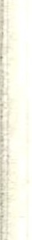
Bio: BA in Russian Language and Literature, University of Washington. Studied at Leningrad University, USSR, 1969-1970. Worked in USSR with traveling American cultural exhibit, 1972-1973. Russian broadcaster, Voice of America, 1973-1978.
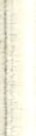
Several management positions with the U.S. Information Agency involving travel to Europe, Latin America. Currently serve as Exchanges Officer in American Embassy, Brasilia, work-ing with cultural exchange programs.

Maxine Kopanski
3240 Scenic Drive
Auburn, WA 98002
(206) 939-9927
Spouse: Stan Selmer
Children: Phillip, -age 17; Stephanie, age 14; Tom, age 10; Katherine, age 6
Bio: For most of the last twenty years, I have been involved with raising our children and keeping semblance of order at home. We moved back and forth to Alaska several times. I was elected to the school board and was active in music in Skagway when we lived there.
Now I am back in college and doing historical research. Phillip graduated from Auburn High School this year and Katherine finished kindergarten.

Joy Kolle
22017 92nd Avenue West Edmonds, WA 98020
(206) 774-6140
Spouse: Bill Tschernega Children: Paul, age19; Brian, age 13
Bio: I have been happily married for twenty years to Bill. Our family enjoys both water and snow skiing. We live in Edmonds and spend most of our summers at Lake Chelan where we have a summer home.

Barbara Lane
10814 4th Avenue West Everett, WA 98204
(206) 353-7250
Spouse: Donald Rasberry
Children: Marie, age 18 and married; David, age 15; Marcus, age 11
Bio: Was married eleven years to Wayne Erwin, the children's father. Married to Don for eight years. We own D & B Trucking and I also drive our 18 wheeler when I can get away.

Bonnie Lewis
6529 Fisher Road
Edmonds, WA 98020
(206) 743-7652
Spouse: deceased
Children: Brent Anderson, age 15; Tera Anderson, age 9

Dave Lewis
15327 Larch Way North Lynnwood, WA 98036

Sandy La Rue (Messner) 3322 123rd Street SE Everett, WA 98204
(206) 337-9635
Spouse: none
Children: Jeana Messner, age 15; Andy Messner, age 12
Bio: The first seven years after graduation I was a hair stylist in Edmonds. Have since become an interior designer and fashion merchandiser through ECC and have worked in the local area. Then I became a florist to incorporate into my line of work.

Arthur R. Lindsay
12831 Jefferson Way
Lynnwood, WA 98036
(206) 743-3045
Bio: Right after high school I went to work for Boeing. Shortly after that,! was drafted into the Army. Since then I have traveled many places and worked at many jobs. Now I only have a couple more years to work and then I will be able to retire and live the good life in Mexico.

Lois K. Manley (Parks) 9815 164th Street NE Arlington, WA 98223
(206) 435-2458
Spouse: Separated
Children: Connie Lynn Parks, age 17, David Scott Parks, age 13, Anna Marie Parks, age 11
Bio: Living on a farm with my three children in Arlington and am presently going to Everett Community College majoring in business.

Ann Marshall
16806 36th Avenue West Alderwood Manor, WA 98037
(206) 743-2466
Children: Amber Stagg, age 19; Marshall Stagg, age 15
Bio: After briefly attending the University of Washington, married and went to live in Taiwan, where my husband was sta-tioned and my daughter was born. Then we went directly to Ger-many, where we lived for four years in Pfalz. My son was born there.
We returned to Lynnwood in 1975 and I began working in my mother's business, which is now the Washington Trails Associa-tion. In a few years I became editor of Signpost Magazine which WTA publishes. Divorced in 1979.
In 1983 my hiking partner and I made a 1,000-mile backpack trip through Washington and Oregon on the Pacific Crest Trail. Afterward, we compiled our journals into a little book, Two on the Trail, which was published last December.
My son now lives with his father in Chewelah. After graduating last spring from high school in Chewelah, my daughter moved back to Lynnwood, where she now lives and works.
Some of my other interests are beekeeping, photography, piano, gardening, backpacking, and skiing.

Terri Martel 16522 112th Lane NE Bothell, WA 98011
(206) 488-7508
Spouse: Bascom Palmer Children: Gretchen, age 15; Kari, age 12

Susan Mc Adams
Route 1, Box 127
Amboy, WA 98601
(206) 269-4551
Spouse: there have been two - you can't print what I call them Children: J. Griogair Bell, age 17
Bio: DWP, 38, 5'5", 118 lbs, still desperately seeking to avoid
growing up. True to Camelot roots through public sector work at federal,state, and local levels.
Have lived in New Mexico, North Carolina, Washington DC, and California. Now back in Washington State, on the slopes of Mount Saint Helens with one son (17), one calf (named Beef Wellington), thirteen ducks, a German shepard, and a Bronco II.
Newest innovation: formed own municipal consulting firm to escape 9-5 schedule.

James R. Mc Cann 11325 21st Place NE Lake Stevens, WA 98258
(206) 324-6976
Spouse: Lorrie
Children: Rauchel, age 13; Jimmy, age 4
Bio: Joined Army in December 1967. Went to Viet Nam from July 1968 to July 1969. Was with the 101st Airborne at Phu Bai. Got out of the service, attended Edmonds Junior College, and stated work at Boeing's Everett Division in June 1974, as a painter. Then I went into Management (Supervision) in 1978. I'm still working at Boeing in Everett; been with the company for twelve years. Live in Lake Stevens with my wife and two children. My hobbies are fishing, and my position as Secretary-Treasurer for the Lake Stevens Chapter of N.W.S. & Salmon Council of
Trout Unlimited for three years.

Patricia McCormick P.O.Box 135 Ivy, VA22945 (804) 293-4840
Spouse: Bruce D. Norris Children: Heather, age 6; Lauren, age 4
Bio: Zeroing in on middle age!

Marsha Merklinghaus 1401 East Reserve Street Vancouver, WA 98661
(206) 694-0243
Spouse: Bill Houghton Children: Chad, age 12; Rachelle, age 10
Bio: Went to business school in 1967 and to work for Alaska Magazine. Was married in 1969 and moved to Wenatchee and then to Ellensburg, working while Bill was in college.
Chad was born in 1973, then we moved to Vancouver, Washington where Rachelle was born in 1976. In 1978 I became active in the PT A and elementary school.
Traveled to Europe in 1979, 80, and 84 for winter ski vacations. Started teaching aerobic dance classes for Vancouver Parks and Recreation.
Linda Misiuda (Hartzell) 6525 27th Avenue NE Seattle, WA 98115
(206) 525-0617

Pamela Mitcham 13411 19th Avenue NE Marysville, WA 98270
(206) 653-2113
Spouse: Paul Jones
Children: Tracy, age 18; David, age 12; Anna, age 7
Bio: The Lord has watched over me and my family for the last twenty years and kept us in His care. I have worked in banking for thirteen of those years, but the best rewards in my life have been to be a wife and mother.
We are enjoying a slower-paced life on twenty-five acres in Marysville. We like traveling, flying, and the Seahawks! I have enjoyed renewing old friendships with my school classmates while working on this reunion.

Michael Monnahan
10822 Rainier Avenue South Seattle, WA 98178
(206) 772-2299
Bio: University of Washington, 1966-1970. Apprenticed as an iron worker. Married 1972. Built home on south Lake Washington, 1977-1978; began general contracting business shortly thereafter. Divorced 1980. Discovered sailing and moved abroad, 1981.
Travels - for work, to South Carolina, Longview, Portland; for fun, to the waters of western British Columbia.

Linda Morley
15801 Cascadian Way
Bothell, WA 98012
(206) 743-6151
Spouse: Dick Kaas
Children: Michelle, age 13; Teresa, age 10
Bio: I have been married for fifteen years out of twenty. Have been busy raising a family, working in the secretarial field as ex-ecutive secretary and administrative assistant in various jobs. Presently working for Intermec Corp in Mukilteo in the Manage-ment Information Systems Department.
Having fun knitting, cross-stitching, and remodeling a 1972 47-foot Pacemaker yacht.

Bill Munson
1230 Freeway Place
Everett, WA 98204
(206) 745-8532
Spouse:Jan Children: Jesse, age 9
Bio: Building boats and commercial salmon fishing. Own Mun-
son Manufacturing Inc, a boat building company in Edmonds.
David Scott Myers 231 West Jensen Street Arlington, WA 98223
(206) 435-5965
Spouse: Erin
Children: Rick, age 15; Sherry, age 13
Bio: Went into the Army; served one year in Viet Nam. Came back and was stationed in Kansas for a yearwith my wife. Got out of the service in 1970.
Came home to Washington; had two children. Went to truck drivers' school and went to work for LeMasters for ten years. Now work for Camano Island Lumber as yardman and truck driver, and have lived in Arlington for the last seven years.


Marilee Nerod (Chevalier)
3314 Fuhrman East
Seattle, WA 98102
(206) 625-9690
Spouse: divorced
Children: perhaps I could borrow some?
Bio: Making up lost time (in advance).

John Nickell
Box 339
Winthrop, WA 98862
(509) 997-7385
Spouse: Debra
Children: Jody, age 17; Morgan, age 7; Maja, age 4
Bio: Western Washington, Bellingham, 1966-1968.
University of Washington, Seattle, 1968-1971, BS, Microbiology. University of Washington School of dentistry,1971-1975, DDS. Public health dentistry two years, then private practice for the past nine years. Presently in Winthrop, Washington.
Flower-child/hippie for four years, yoga for four years, housebuilder, orchardist. Traveled U.S., Mexico, Central America. Looking foward to southern hemisphere travel.

Kenneth Novak
1583 South Lake Drive Camano Island, WA 98292
(206) 387-6730
Bio: Moved to Anchorage, Alaska, right after school. Worked as a heavy equipment operator all over Alaska for 18½ years. Just moved back to Washington eighteen months ago.

Dennis K. O'Neil
1523 Douglas Street Mount Vernon, WA 98273
(206) 336-2647
Spouse: Dimity

Raymond D. Payne
4214 Anza Borrego Court Pasco, WA 99301
(509) 547-8097
Spouse: Sherry Children: Jason, age 9
Bio: Painting contractor, 8 years. Teaching degree, 1974, Cen-
tral Washington.

Carl Pearson
P.O. Box 698
Mukilteo, WA 98275
(206) 355-8628
Spouse: Sandra

Linda Pearson
East 301 Country Club Drive
P.O. Box 698
Allyn, WA 98524
(206) 275-6853
Spouse: Mark Magnuson
Children: Becky, age 14; Mike, age 12; Shane, age 2

Jerry L. Pate
21109 - 95th Street S.E. Snohomish, WA 98290
(206) 794-8646
Spouse: Robin Children: Jarin, age 14
Bio: Shortly after high school I took up a career in construction as an apprentice in the controlled use of explosives for road con-struction. This type of work includes a lot of traveling: Washington, Oregon, Idaho, Montana and Alaska. As the years went by I became an experienced journeyman and really enjoyed the challenges and rewards of my craft.
Now days, I am a business representative for the Laborers In-ternational Union of North America, Laborers Local 440 in Seat-tle. This is definitely a demanding, trying job, but I do feel it's a very important one. I represent several thousand working men and women in the construction industry in our area, and am more than happy to do so.
I was married in 1969 and divorced in 1972. Stayed single for four years and then married Robin 1976. Best move of my life. I now have a wife and son who will work with me, love with me, and enjoy whatever God has laid out for us in our lives. We live on 5.25 acres in Snohomish that we developed ourselves, and tru-ly enjoy the country life.
We have traveled in Washington, Oregon, British Columbia, Iowa, Kansas, Florida, California, and Nevada - plus one five-day trip to Jamaica: never again out of the country. The good old USA is for us. We enjoy camping, hunting, and fishing along with many other outdoor sports - the same things that got me in trouble in school by being absent so much!
My memories of good ol' MHS are truly cherished ones, as things were so simple then. I am looking forward to this twenty-year reunion, as I missed the ten-year get-together. It will be neat to see you all again. I feel that I am where God wants me to be in my life and if I can keep it simple and live one day at a time, I will enjoy the rest of my life as God has meant it to be.
Hopefully, we can have more get-togethers, formal or infor-mal," and not so many years apart.

Larry D. Paulson
2320 - 163rd Drive S.E. Snohomish, WA 98290
(206) 335-0817
Spouse: Laura
Children: Duane, age 18; Tammy, age·17
Bio: Been working construction for the last twenty years. I have been divorced and have remarried. While working in Hawaii the past five years, I met my wife Laura. We moved back here from Hawaii last year and enjoy the Pacific Northwest a lot better.

Robin Pittis
7507 - 35th Street N.W.
Gig Harbor, WA 98335
(206) 265-3692
Spouse: Jerry Lee Sage
Children: Vanessa Noelle, age JO; Chad Micha, age 8; Jamie Nicholle, age 6
Bio: Graduated from Western in 1971 with a BA in Education.
Taught two years in Edmonds, grades five and six.
Jerry and I bought 1-1/4 acres in Gig Harbor and built our own house (designed and constructed). Had three babies over four years. I am now teaching kindergarten in Tacoma.
Jerry and the kids and I love hiking, cross-country skiing, and the ocean. We are dedicated Tacoma Stars Soccer fans, and all three of our children play soccer. We recently bought an acre of ocean-front property in Grayland, so between the family cabin on Snoqualmie Pass and the ocean, our weekends are extr_emely busy!

Farol Pubmire
1175West4005
Cedar City, UT 84720 (801) 586-8446
Spouse: Brent Hunter
Children: Lonn, age 17½; Heidi, age 16; Brandon, age 14; Jill, age II; Craig, age 7; Clay, age 5; Dane, age 3
Bio: I have been very involved in raising my children until January of this year when I enrolled in college again as an attempt to finish my degree. I have two years remaining and am studying business education.
My husband is self-employed; we have a farm and raise sheep for a living. For fun I jog and do aerobic exercise and enjoy sing-ing. I taught piano lessons for a number of years but cannot think of any other achievements.
I am very happy here in southern Utah and will probably re-main here. We came back to visit my family that is still up there for the first week of July, and were reminded of the beauty of the
area - and also of its damp, rainy climate. It's very dry here, but I have grown to love it and the friendly people.
I would love to come to the next reunion you have!

Nancy Raethke
723 S.E. Peacock Lane Portland, OR 97214 Spouse: Steven Tuttle
Children: Two, ages 14 and 9
Bio: Traveled to Turkey, most of the USA, Hawaii three times. Present job: executive secretary for Good Samaritan Corp in Portland, to chief financial officer/senior vice-president.

Geri Ritchey
2219 Highland Avenue
Everett, WA 98201
(206) 259-2371
Spouse: Ray Reed
Children: Kimberly, age 15½; Bryce, age 17


Greg Rice
1020 Idaho
Libby, MT 59923
(406) 293-8275
Spouse: Susie Harter Children: Cressey, age 12
Bio: In 1970, Greg graduated from the University of Washington, and Susie from Western Washington University. Our wedding followed a week after graduation. We spent four years in Saint Louis - Susie teaching; Greg attending medical school. Following a three-year family practice residency in Seat-tle, we settled in Libby, Montana - a small town tucked in the northwest corner of the state, 170 miles from Spokane (we're right on the way to Glacier Park).
Greg is busy as a family doc, but still finds time to bike race and coach a cross-country ski team. After working in our office for seven years, Susie quit and now keeps too busy with a variety of youth programs. As a family, we enjoy bike touring and cross-country skiing.
Our daughter, Cressey, will be entering junior high in the fall. She's following in Greg's footsteps in track - breaking city records, especially in longer distances. She looks forward to runn-ing cross-country and dreams of competing in the Olympics in cross-country skiing.

Howard Riser
922 - 208th N.E.
Redmond, WA 98052
(206) 868-1326
Children: Rebecca, age 12
Bio: Army, four years, Viet Nam vet. Worked as a janitor for five years, the last 2½ attending junior college. Have been work-ing at Boeing the last eight years, the last I½ years in Las Vegas on field assignment.

Marie Robbins
Route 1, Box 194
Snyder, OK 73566
(405) 569-2774
Spouse: L.W. "Butch" Schmit
Children: L.W. "Lance", age 16; Kevin D., age 14
Bio: Butch is in his twenty-third year of Air Force service, so upon retirement we'll have to settle down. We've lived in Florida, Texas, California, Turkey, and currently in Oklahoma. •
My jobs have changed with each move. Now I am the assistant manager at the Altus Air Force Base liquor store which sells over
$1 million per year, so am busy keeping up. Both sons are active in sports and band. Stock car racing, motortcycle touring and weekend camping keep us all going at a fervent pace.

Jeanne Robinson Route I, Box 597 Ellensburg, WA 98926
(509) 964-2027
Spouse: Walt Birchen
Children: Jody, age 17; Kacey, age 11; James, age 7
Bio: Twenty years indeed! I only wish I could be with everyone. Well, let me see...After going to college for a while I started a banking career in foreign exchange for about eight years. I made a move to Oregon where my husband had a family business and then to Point Barrow, Alaska, located at the top of the world -
526 miles North of the Arctic Circle. An unforgettable ex-perience, to say the least!
We then drove the Al-Can Highway through all of the Yukon Territory and settled in Ellensburg. Both of us worked for Stuart Anderson's Black Angus Cattle Company Ranch where I gave 4-H tours and co-ordinated ranch activities and parties for large numbers of people.
We then tried our hand at raising thoroughbred race horses. I have worked with a breeding farm for the last two years, handling stallions, brood mares and foals. I'm now in the process of train-ing young colts for the race track. Some of "my babies" have recently run at Longacres, Yakima Meadows, Arizona, Florida, and Minnesota. I'm busy, to say the least!
My oldest daughter Jody will be a senior at Edmonds High School. Kacey, age 11, is training with her pony in barrel racing and hopefully will be ready for this year's Ellensburg Rodeo for her age group. James is 8 years old and plays soccer.
Hope this note finds everyone healthy and happy. Best years to come!

Don F. Rosebaugh
20806 - 144th Avenue S.E. Kent, WA 98042
(206) 631-7550
Spouse: none Children: none
Bio: College, job, marriage, homeowner, divorced. I've been a banker the past twenty years. Have been self-employed the last four years as a writer/research analyst for a consortium of small banks.

Sharon (Sherrie) Rueter 20427 S.E. 24th Street Issaquah, WA 98027
(206) 392-2451
Spouse: Bill Schoentrup
Children: Will, age 16½; Jamie, age 10½; Rickie, age 6½; Christina Ann Jin Hee, age 4
Bio: I've been married to Bill since January 1967. We lived in
Redmond 7½ years, then moved to Issaquah where we live now. We have three sons of our own and have adopted a little girl from Korea; she is our only daughter.
I have gone to school a lot and now own my own small business. The name of my company is Horizon of Colors. I am a cosmetologist, make-up artist, color analyst consultant, wardrobe consultant, and lecture on color and color analysis, skin care, and make-up application. I am very active in our church. I'm a first-grade teacher of religion, and Bill and myself are the coordinators of our nursery at the church. I babysit twenty-eight children 4½ years and under during church on Sunday, and coordinate three other nurseries during Sunday masses.
We are also delegates for an exchange program. Our students are from the ages of 9 through 17 years, and are from Mexico, Panama, and Costa Rica. We are always looking for host families. We will be going to Mexico this summer with the pro-gram. Bill and myself are also in Marriage Encounter with our church. We live very busy lives w_ith our activities and our four children.

Marie Scales
East 916 - 19th Spokane, WA 99203
(509) 455-9309
Spouse: Dennie Mroczek
Children: Dennis, age 18; Andrew, age 17; Krisha, age 13
Bio: Been there...done that. See me for details!

Jim Scalf
P.O. Box 946
Snohomish, WA 98290
(206) 337-7710
Spouse: Sharon Warren
Bio: Living!

Ann Schmiedeke
21520 S.W. Imperial Court Aloha, OR 97006
(503) 642-3226
Spouse: Tony Cox
Bio: I am an elementary music specialist and have been teaching in Hillsboro, Oregon, for the past eleven years. Previous to that I taught in Washington. My husband is also a teacher.
We like to travel, camp, ski, and backpack, and are both active in professional organizations.

Lois Schultz
15557 Midvale North
Seattle, WA 98133
(206) 364-1031
Spouse: John "Jack" Kropp
Children: Cindy, age 20; Robert, age 16; Richard, age 6
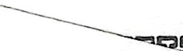
Bio: Remarried in March 1979. I drive a school bus for the Shoreline School District. We enjoy hiking and climbing.
Shirley Sheehan 10531 N.E. 148th Court
Bothell, WA 98011
(206) 488-8573
Spouse: Bob Pelan
Children: Sean Pelan, age 18; Seamus Pelan, age 15

Pamela Sisson 14844 N.E. 11th Place Bellevue, WA 98007
(206) 64 I-7505
Spouse: James J. Hagen
Children: D"avid Hagen, age 19; Ann Hagen, age 17
Bio: Here is a brief description of the last twenty years; I surviv-ed a divorce and remarried a wonderful man 1with two small children, eight years ago. Our family enjoys sailing adventures, including having just returned from Expo '86 via the San Jan and Gu.If Islands.
For the last two years I have been very busy with my Accounts
Receivable consulting business in the transportation industry.

Julie Slocum (White)
9226 - 20th N.E.
Seattle, WA 98155
(206) 523-5169
Spouse: nonexistent
Bio: I have four children for which my nonhusband "forgave" me for having so many - Joseph, age 14½; Josua, age 11; Jessamyn, age 8; Jade Infinity, age 5. I have worked alone for the last four years to support them. I went from cashier to dining room supervisor to assistant manager in the same restaurant.
After almost dying once myself and watching two people I lov-ed die within a month recently, all other accomplishments have no value to me at this time. I love my kids, I'm glad to be alive, and everything else is false values and pretenses which make us "valuable" by workday values.

Barbara Sparks
P.O. Box 693
Mukilteo, WA 98275
(206) 355-3759
Spouse: Peter Spofford Children: I forgot!
Bio: Currently non-career-oriented employee of Washington Dental Service.
Active inte_rest - mushroom picking, golfing, and sailing. Favorite pasttimes - telling dirty jokes; goofing off and wasting time; battling anorexia!
Since fads go in twenty-year cycles, next year I am going to be a hippie, and the year after that I am going to be SERIOUS.
I haven't changed a bit!

Diana Staats (Mothersbaugh)
7011 - 177th Street S.W. Edmonds, WA 98022
(206) 745-3554
Children: Tawnya, age 18, Jason, age 14
Bio: Eight years San Jose, California. Four years Lake Tahoe
- waitressing! One year Las Vegas. Cowboy, rodeo pastel artist, lived in Colorado Springs, Colorado. (I must have been raising kids most of the other seven!)

Bonny Stathem
1133 - 164th Street S.W. Alderwood Manor, WA 98037
(206) 743-5338
Spouse: Ken G. Eisen
Children: Angelea Le Anne Eisen, age 15; Andrea Dawn Eisen, age 10½

Stanley Stebing
222 - 143rd Street S.E. Everett, WA 98204
(206) 743-7994
Spouse: Sherry Look (MHS, '68) Children: Scott, age 10; Staci, age 8
Bio: After high school I opted to work in the grocery industry as a clerk, as a sales representative for T.J. Lipton Ines, and as a route salesman for Pepsi Cola Bottling and Clark Distribution. Sherry and I were married in June 1968, with Scott being born in April 1976, and Staci in November 1977.
After being out of school for eighteen years, I went back to school in September 1984. In August 1986, I will receive AAS degrees in electronic technology and digital computer electronics. Sherry and I did our traveling before we had our kids and are now very content with our camping vacations. Even though my body is getting older, my mind still thinks that I am not long out of high school, which is my explanation for owning a 1939 Chev
P/U streetrod and still enjoying sixties music.

Chuck Steinberger 2616-C Waynick Street High Point, NC 27260 (919) 841-7131
Spouse: Lesley
Bio: Past three years national sales manager for the south's largest home sewing and needlework distributor out of Atlanta. Just recently opened own small company in North Carolina im-porting French hand knitting yarns. Married last Thanksgiving for the second time. Sorry I won't be able to make it - see you in
five years.

Jan Syltebo
Route I, Box 3 Cataldo, ID 83810
(208) 682-2608
Spouse: Ken Tilton

Vern Taylor
10711 - 90th Street N.E. Lake Stevens, WA 98258
(206) 653-1206
Spouse: Linda Wheeler
Children: Keith, age 15½; Chad, age 121/:; 1 ,a, age 8½
Bio: During the past twenty years, we have bee.i married 17 ½ of those years. Vern served in the Navy, then as been in, abinet work since. After staying home as a full-time mother for ten years, Linda went to work as a school secretary.

Don Thompson
23513 - 51st Avenue S.E. Woodinville, WA 98072
(206) 481-3490
Spouse: Susan
Children: Mason, age 7; Bryn, age 5
Bio: I attended Washington State University for a year after high school, then did a short active duty stint in the Navy. I returned to the University of Washington and earned a BS in wildlife biology. Susan Akers (class of '67) and I married in 1972. We lived in Woodinville with our sons.
I've worked for the Bellevue Fire Department for the last ten years and very much enjoy the time it affords me with my family. In the past several years our family has realized the importance of our personal commitment to Jesus Christ and we have been work-ing to revitalize that relationship.

Dennis Tibke
17414 - 36th Avenue West Lynnwood, WA 98037
(206) 745-8973
Spouse: Claudia
Children: Terry, age 8; Brian, age 6; Mike age 4
Bio: I have three boys who keep Claudia and me very busy. I have been playing slow-pitch since I was in school. I have been working as a carpenter for the last nine years.

Joe Turner
location confidential Spouse: divorced Children: none
Bio: After leaving Meadowdale, I attended the University of Washington for a couple of years, then "dropped out" to be a ski bum on the European pro circuit for about three years. In 1975 I graduated from Harvard with a degree in international law, but before I ever got a chance to settle down, I became involved in some undercover, work for the Central Intelligence Agency, which made use of the connections I had developed while living in Europe.
This work was a turning point in my life. From Europe, I agreed to as assignement in Southeast Asia, and after the ruckus from that died down, I was given a third - and, so far, final - assignment in South America.
My testimony at Amnesty International put me on every ter-rorist's "hit list," so now I'm keeping a low profile in a spot where the climate is warm and the politics are hot. Have kicked the drugs, including nicotine, and have managed to set myself up with a comfortable, if modest, life here.

Linda Tutmark
612 - 140th Place S.W.
Lynnwood, WA 98037
(206) 743-6048
Spouse: Thomas Krolik

Marty Tuttle 7811 East Glen Drive Everett, WA 98203 Spouse: Salli Bevan
Children: Tanya, age 18; Martin, age 15; Nicholas, age 3 months
Bio: Secret.

Tim Tuura
734 - 14th Way S.W.
Edmonds, WA 98020
(206) 774-1983
Bio: Walla Walla Boys Camp, eight years.

John "Steve" Uram 3229 - 108th Street S.E. Everett, WA 98204
(206) 337-9704
Spouse: Carolyn
Children: Jennifer, age 16; Kristin, age 13
Bio: After spending seven years in the Army, during which Carolyn and I met while I was stationed at Fort Knox, I began my career in law enforcement. I served seven years with the Jefferson County Police in Louisville, then we moved home to God's Coun-try. I am now a detective with the Everett Police Department and Carolyn is an office manager in Mukilteo.

Lynne Wagner
207 South 46th
West Richland, WA 99352
(509) 967-2395
Spouse: Bob Paasch
Children: Tyler, age 14; Travis, age 11; Ryan, age 4
Bio: Hello! Bob and I were married in 1980, and his grandson Ryan joined our family in 1984. In 1983 I quit working outside the home as an assistant vice president in mortgage banking. Early in 1985, though, I spent six weeks in Hawaii, working on my father's Wailea Point residential project.
Bob and I enjoy flying in our Piper Lance; we're avid Scuba Divers and duplicate bridge competitors when we're not enjoying the boys' numerous activities and the on-going renovation of our home. Three weeks in Europe last November was a special treat.

Larry Walker
8620 - 3rd Avenue N.W.
Seattle, WA 98117

Gene Walters
10709 - 159th Court N.E. Redmond, WA 98052
(206) 885-9913
Spouse: Marilyn
Children: Chris, age 16; Jake, age 8; Leanne, age 5
Bio: Graduate of Western Washington University. Served six years in the Army as a helicopter pilot. Presently employed with Sundstrand Data Control Inc. as an engineering manager.

Alan L. Warberg
10213 - 18th S.W.
Seattle, WA 98146
(206) 763-4543
Tim Weller 22910 - 29th West Brier, WA 98036
(206) 774-5678

Barbara White (Zackrone)
12325 Maplewood Avenue
Edmonds, WA 98020
(206) 743-4846
Companion: Nolan "Tim" Foss Children: Keith, age 11; Kristen, age 7

Linda Wheeler
see Vern Taylor

Rick L. Whetzel
1507 - 128th Street S.W.
Everett, WA 98204
(206) 743-6770
Spouse: Mary
Children: Trevor, age 17; Chad, age 11
Bio: Electrical contractor; own Electric Home Service. Various travels - Caribbean cruises, Disneyland, and Disneyworld.

Michael Wickstrom
10818 S.E. 293rd
Auburn, WA 98002
(206) 833-0399
Spouse: Cheri
Children: Phoedra, age 15; Erik, age 13; Alethia, age 12; Grant, age 8
Bio: I've been working in warehousing for most of the past
twenty years. For fun we enjoy snow skiing (Lake Tahoe this winter), backpacking, climbing (Mount Rainier summit was a highlight), camping and running.

Teri Williams
P.O. Box 53142
San Jose, CA 95153
Children: Michelle, age 12; Nathaniel, age 10; Mark, age 7
Bio: Flew with Alaska Airlines and TWA until 1972. Commit-ted life to the Lord in 1972 and have been active in ministries. Own a fund-raising business in San Jose, California, after leaving IBM this year.

Linda Wood
9419 Woodbine Street Chilliwack BC, Canada V2O 5S5
(604) 795-5392
Spouse: Bruce Williams
Children: Andrea, age 19; Megan, age 17; Roger, age 14 Bio: I've been a housewife and mother for the past twenty years. (sounds depressing, doesn't it?) I've lived a lot of places across Canada and even in Boston, Massachusetts, for a short time. I was divorced ten years ago and remarried in 1978.
Bruce and I have been living in the Chilliwack area since then. I've been working as a certified dental assistant for the last seven years and really enjoy my job.

Guy S. Woods
31820 - 53rd S.E.
Federal Way, WA
(206) 927-2601
Spouse: Helen
Children: Tammy, age 14; Karen, age 12; Nathan, age 10

Karen Yeager (Woodsum)
609 O'Farrell Avenue S.E.
Olympia, WA 98501
(206) 786-5014
Children: Arwen, age 13; Jessica, age 9
Bio: Have traveled many parts of the United States, living in San Francisco, Georgia, and Boston. Working currently at Head Start. I coordinate programs for handicapped children from birth to age six.

Ed Zachary
P.O. Box 5984
Lynnwood, WA 98036
(206) 353-7841
Bio: Joined the Navy in 1965; discharged in 1969. Moved to Hawaii for two years; moved back to the mainland in 1971.
Became a long-haul truck driver and own my own semi. Never been married.

Dave Zehrung
313 Stagecoach Cr.
Gallup, NM 87301
(505) 863-5182
Children: Kitrina, age 14
Bio: Attended college, receiving Bachelor's Degrees in history and P.E. Wrestled in college, twice placing in the Nationals and winning a World Championship. Served three years of military service. Currently a teacher/coach and have coached two team state champions.



IMPORTANT INFORMATION
Please send updated information to: PAM MITCHAM JONES
13411 - 19th Avenue N.E.
Marysville, WA 98270 or
MARILYN MILLER ECHELBARGER
P.O. Box 1
Lynnwood, WA 98046

PHOTOGRAPHS
Additional Black & White photographs may be obtained from: GALLERY & SONS PHOTO STUDIO
3231 Broadway, Suite A Everett, WA 98201
(206) 252-5945

5 X 7 Black & White - 4.00 each
8 X 10 Black & White - 8.00 each

Name: Address:
Phone: _ Page in reunion book: Quantity: Total Price: _

SEE l�OU IN 5 YEARS!

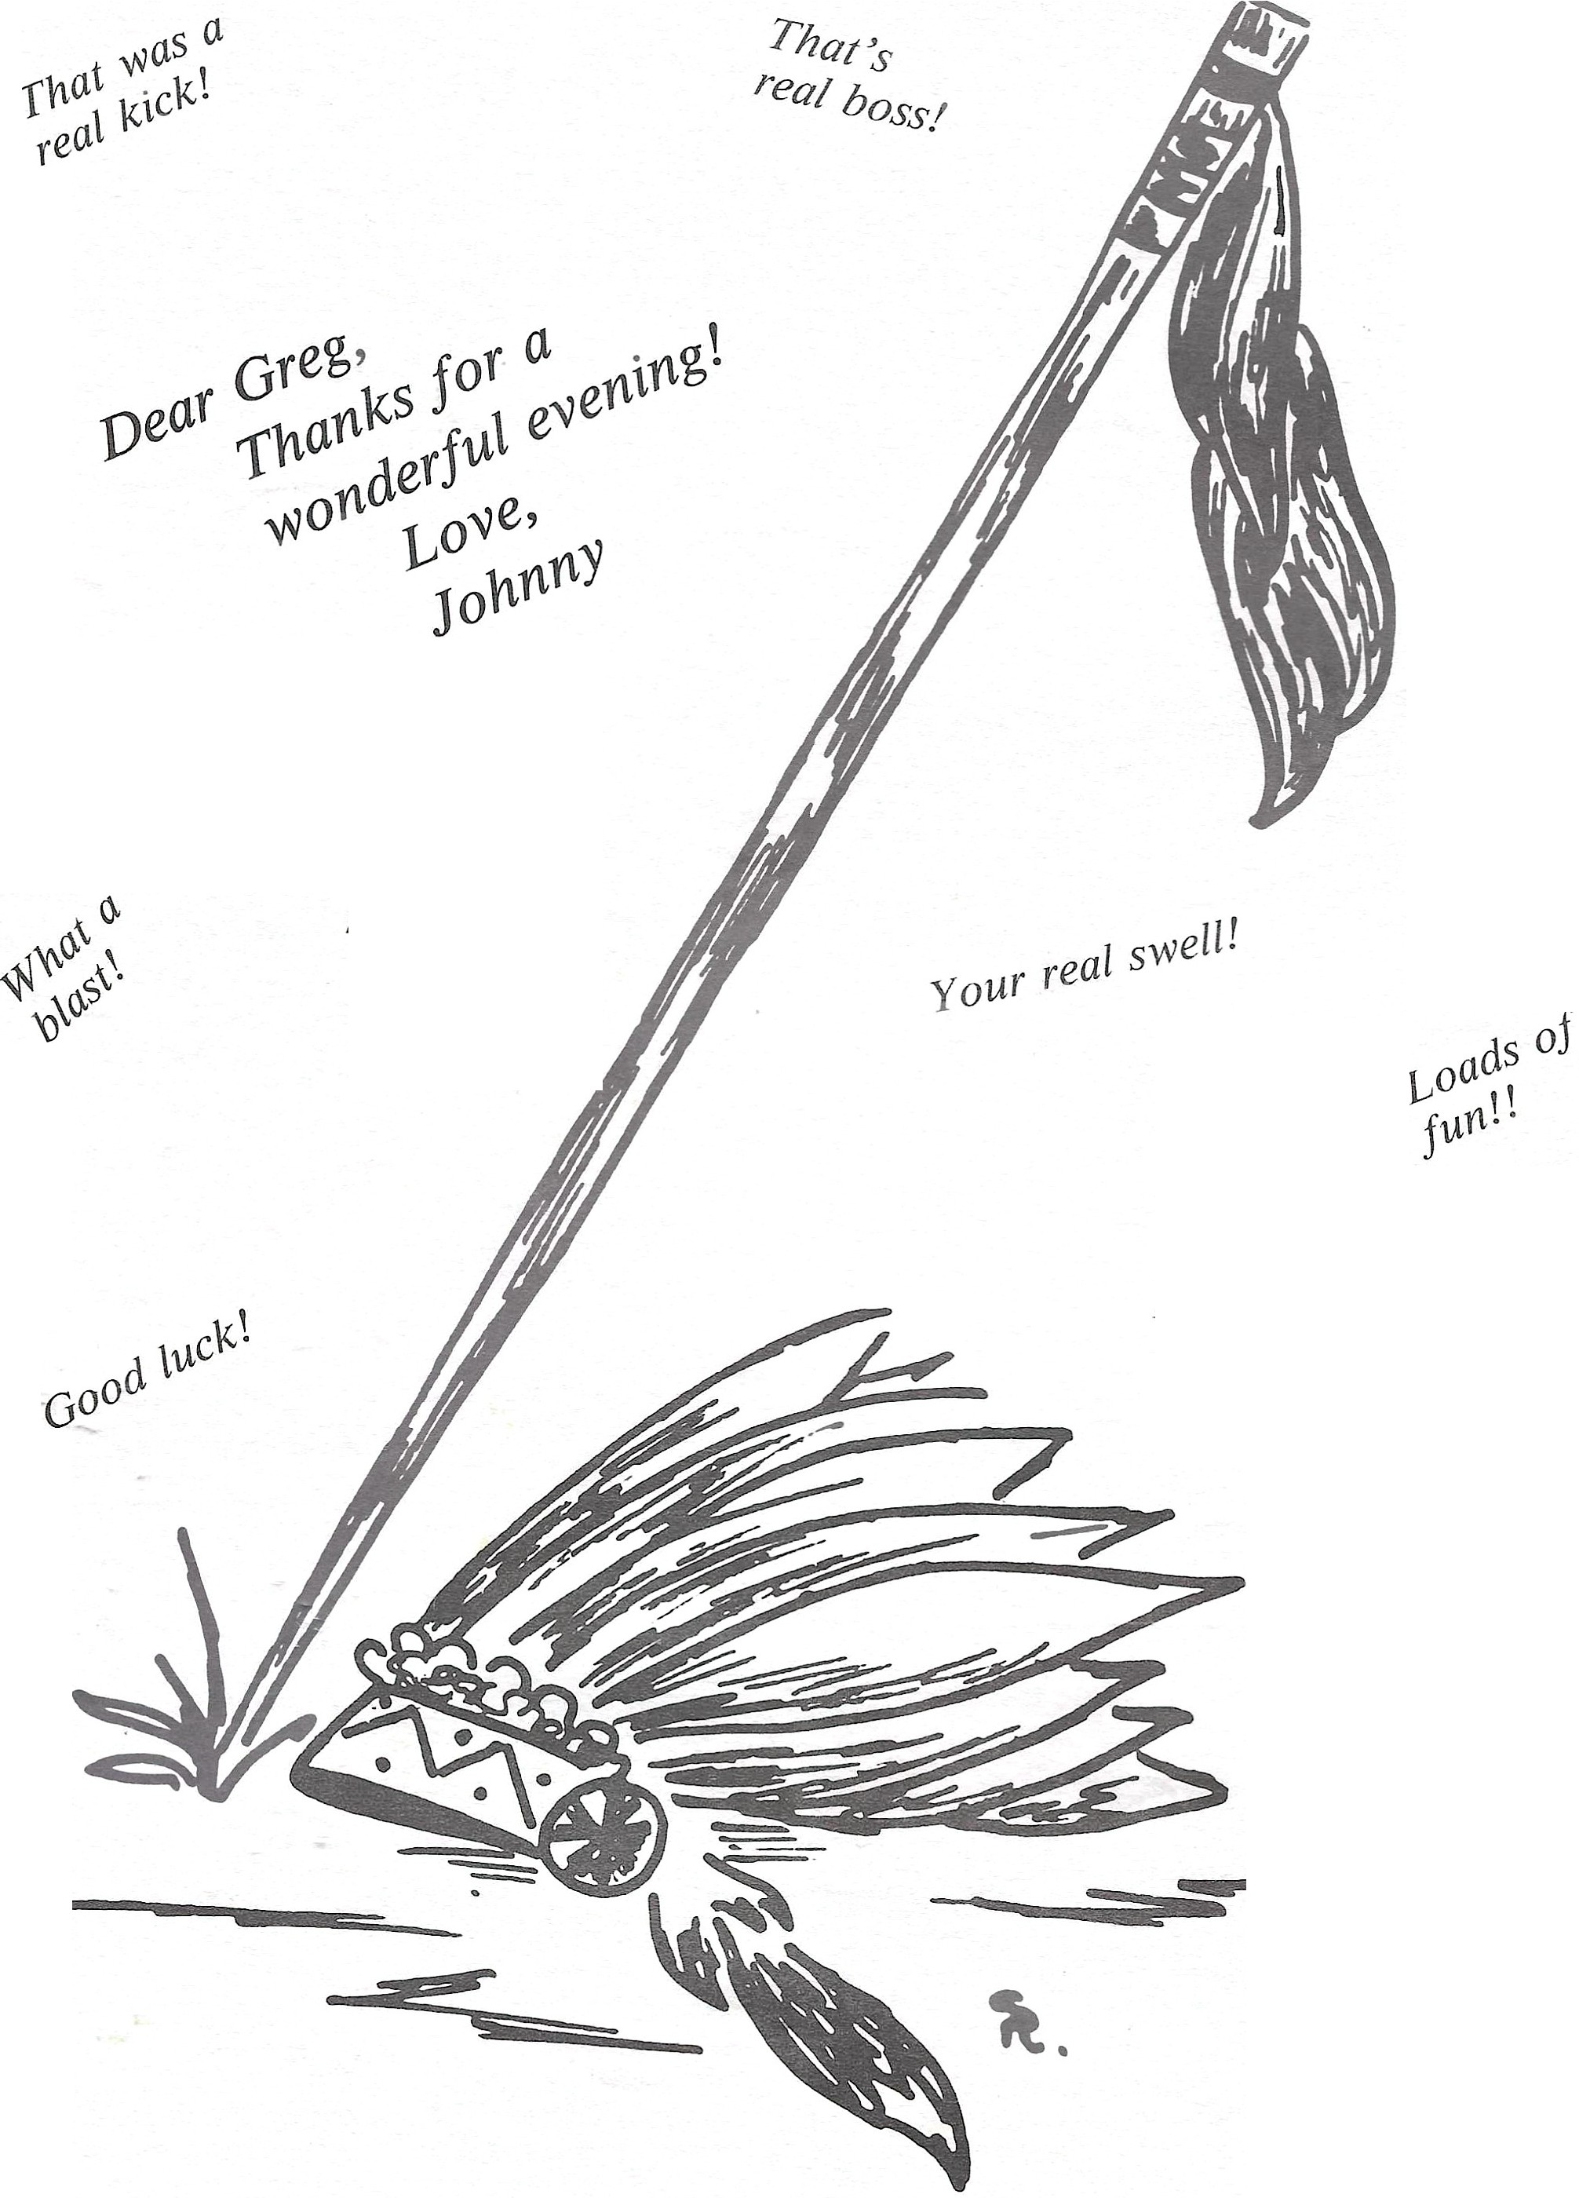

It wasa
real bitch • ,
reunt.on! zn

Bestof luck/

